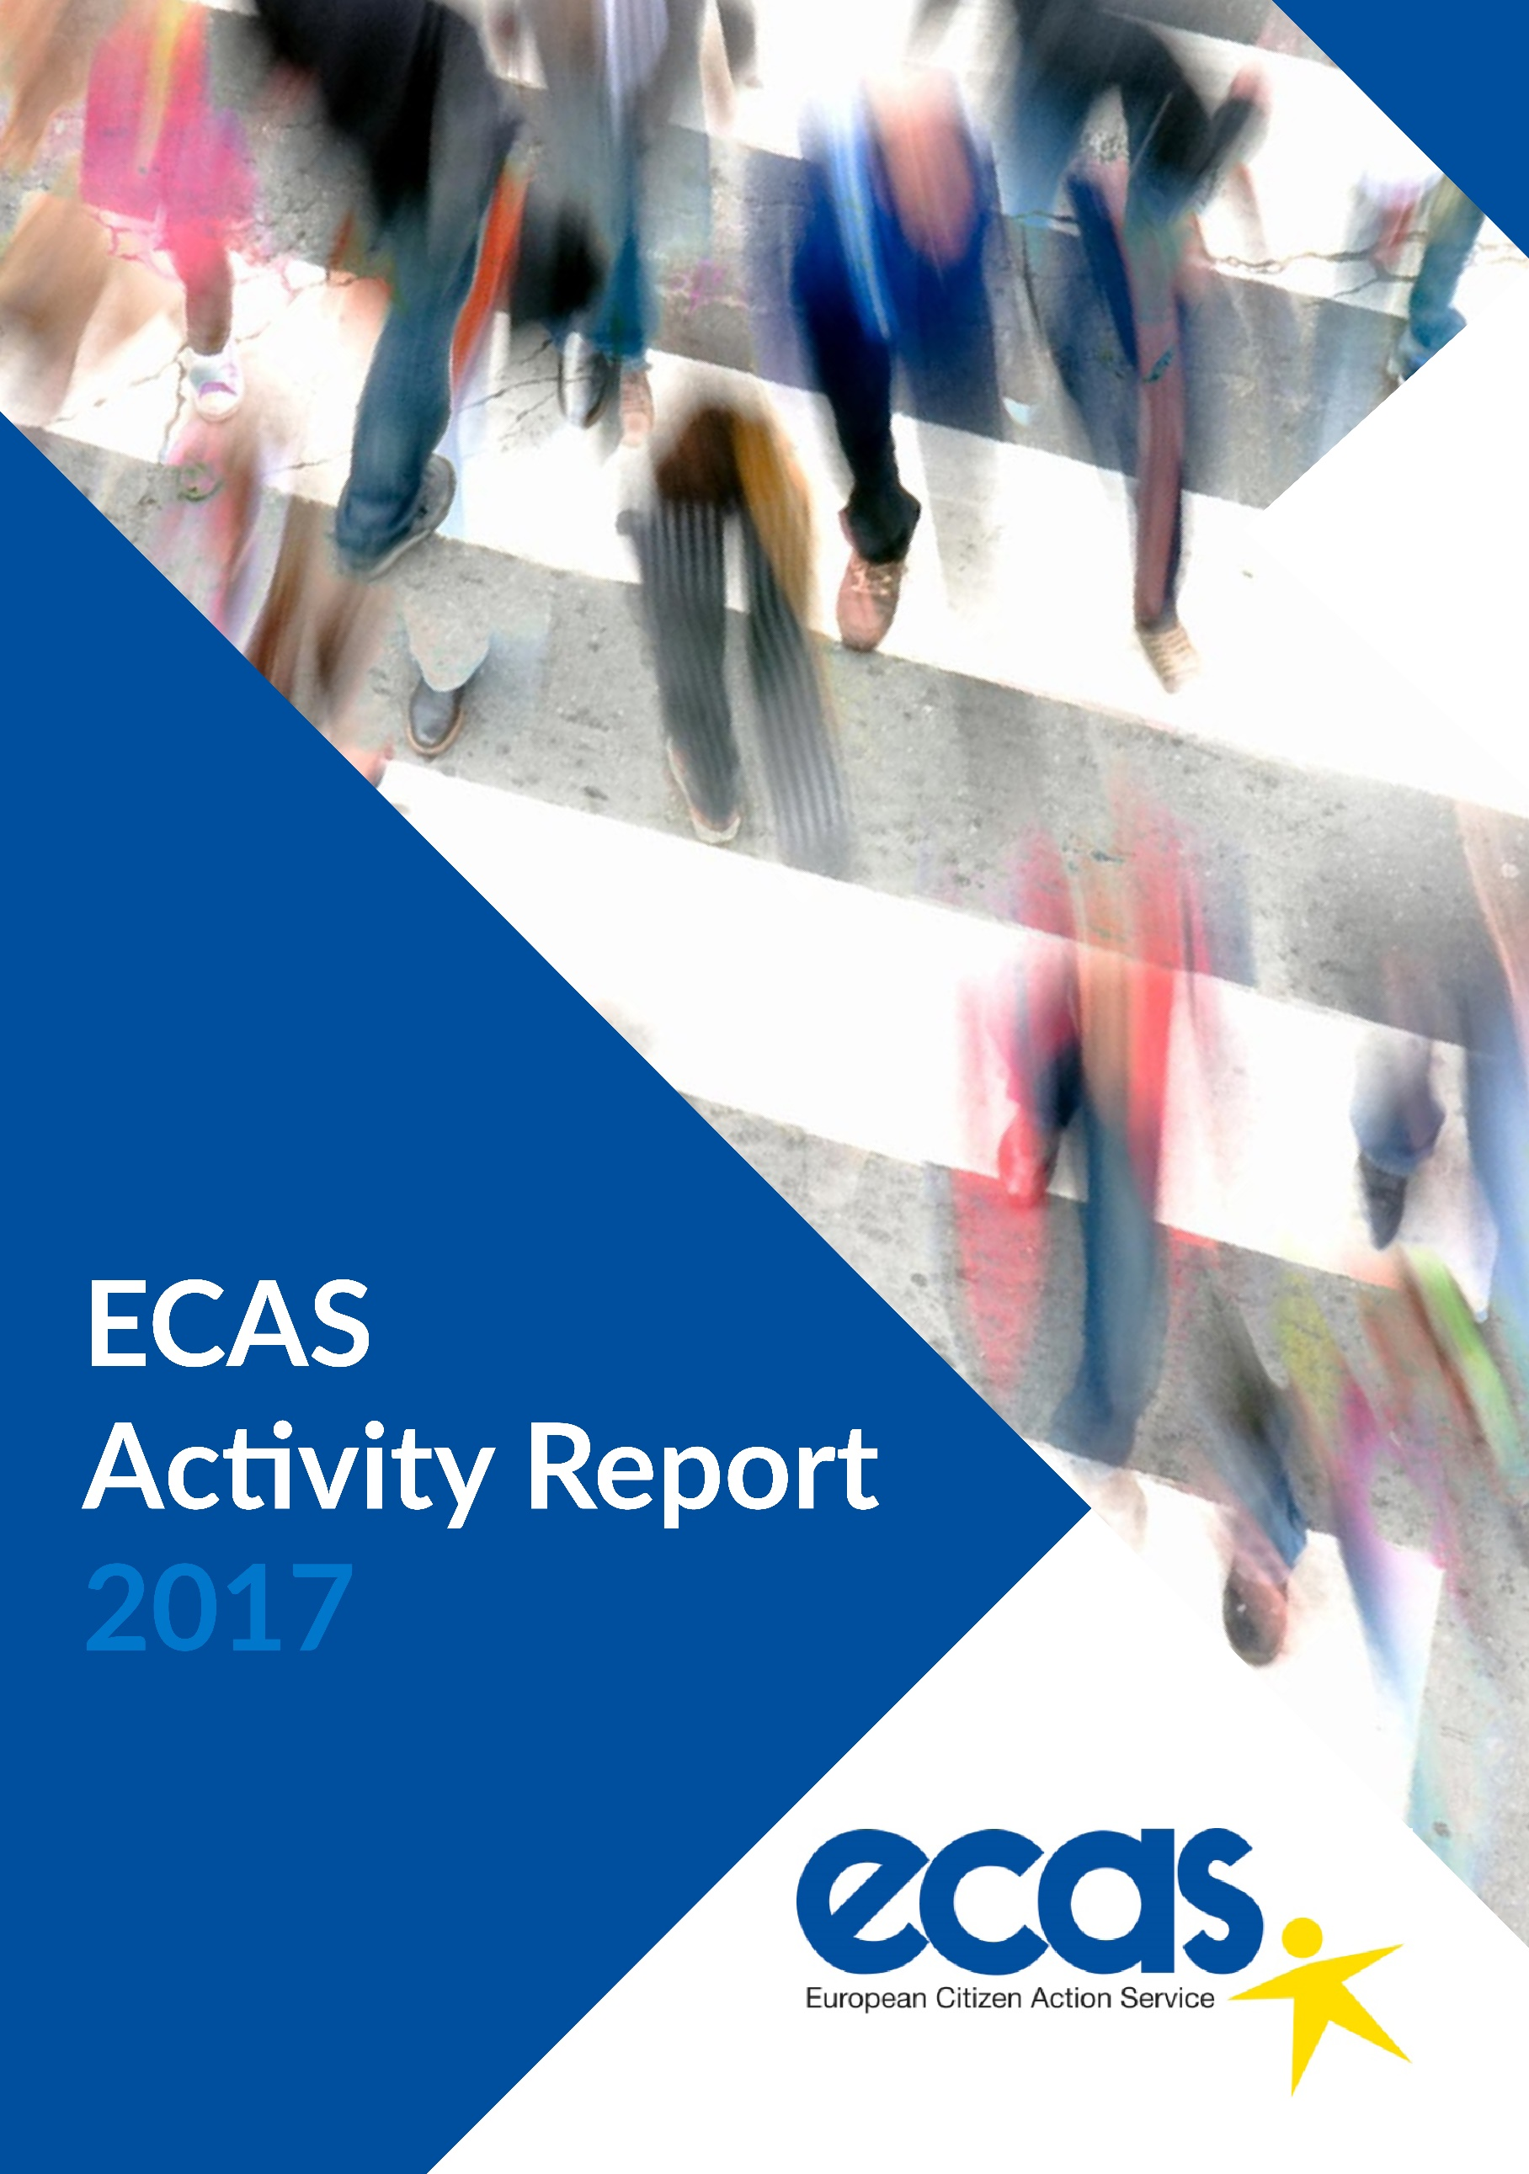

Table of Contents
Table of Contents 3
SUMMARY 5
EU RIGHTS Focus Area 7
Services to Citizens 9
Your Europe Advice 9
EU Rights Clinic 15
Citizen Brexit Observatory 18
Projects 19
5 Takeaways on Brexit: Outlining Possible Scenarios for a New UK-EU Relationship and their Impact on Citizens 19
One Stop Shop for Political Participation of Mobile EU Citizens 20
ACT for Free Movement 23
Events 26
Brexit and Citizens’ Rights in Northern Ireland 26
Free Movement of Persons in the EU: A Loved and Feared Reality 27
Brexit and Citizens’ Rights: The Case of Gibraltar 28
Brexit and Citizens’ Rights: Where Do We Go From Here? 29
Research Studies 29
5 Takeaways on Brexit: Study on Brexit and Citizens’ Rights 30
Brexit and the European Arrest Warrant: How Will Change Affect the Interests of Citizens? 30
Brexit and Loss of EU Citizenship: Cases, Options, Perceptions 32
Policy Positions 33
EU Citizenship Report 2017: More Action Needed to Safeguard Freedom of Movement 33
ECAS Response to the Public Consultation on EU Social Security Coordination 34
ECAS participated in the rapporteur’s consultations with civil society 35
ECAS’ Position on More or Less Europe 35
Press Release: What Do Citizens Want From Brexit? 36
The REFIT Opinion on the Citizenship Directive 37
EU Rights Clinic Calls For Rights of Family Members and Carers of EU Citizens to be Safeguarded Post-Brexit 38
ECAS’ contribution to the European Parliament Citizenship Report 2017 38
DIGITAL DEMOCRACY Focus Area 39
Services to Citizens 40
ECI Support Centre 40
Projects 41
DEEP-Linking Youth 41
EUCROWD 42
Events 43
ECI DAY 2017: I participate! 43
EESC Civil Society Days 44
Digital Democracy Day 2017 45
Beyond Fake News: A Workshop on Media Literacy and Fact Checking 46
Research Studies 47
EU Public Consultations in the Digital Age: Enhancing the Role of the EESC and Civil Society Organisations 47
E-Participation Guidelines for Decision-Makers: Social Listening Through the Digital Dashboard 47
Recommendations on Learning Mobility: Insights from the Digital Dashboard 48
Policy Positions 49
PETI Hearing - Restoring Citizens’ Confidence and Trust in the European Project" 49
Contributing to EU political groups and think tanks 49
DG CONNECT Future Of Government 2030+ - Participatory Workshop 49
ECAS’ Response to the Public Consultation on the European Citizens’ Initiative 49
ECAS’ Call for Enhanced Digital Democracy in the EU at EESC Debate 50
ECAS welcomes Parliament’s e-democracy report 50
Digital Democracy Could Engage Citizens in Europe – ECAS’ Director in Europe’s World 51
ECAS Services to Members and Civil Society Organisations 52
Services to Members 52
ECAS Funding Guide for the Non-Profit Sector 52
Training Centre 52
ECAS’ Outreach 53
Overview 53
ECAS’ Communications 53

SUMMARY
ECAS’ Mission is to empower citizens in order to create a more inclusive and stronger European Union by:
- Promoting and defending citizens’ rights.
- Developing and supporting mechanisms to increase citizens and citizen organisations’ democratic participation in, and engagement with, the EU.
ECAS’ Vision is an inclusive, transparent, citizen-centric and democratic European Union in which citizens’ rights are at the heart of decision making at all levels and in which citizens are informed, consulted and actively participate.

ECAS’ work is focused on two main areas: EU Rights and Digital Democracy. In addition, ECAS provides services to its network of about 100 members as well as numerous civil society organisations in the EU and beyond.

In 2017, ECAS’ work in the EU Rights focus area was marked by:
- Development for the first time of a report on the annual trends of Your Europe Advice (YEA) enquiries which was presented at ECAS’ conference – ‘Free Movement of Persons in the EU: A Loved and Feared Reality and reflected in the media.
- Development and awareness raising of the study ‘5 Takeaways on Brexit: Outlining Possible Scenarios for a New UK-EU Relationship and their Impact on Citizens’, which was viewed by more than 15,000 people.
- Launch of the Citizen Brexit Observatory (CBO) - a collaboration between ECAS, Sheffield University and the Law Centres Network (LCN) - with the objective to support the fair treatment of EU citizens living in the UK and UK citizens living in the other countries of the EU.
- Submission by the EU Rights Clinic and ECAS in cooperation with Crossroads Göteborg of a complaint to the EC related to a breach of Free Movement Rules by Sweden on behalf of 285 individuals and a petition to the European Parliament.
- Submission and draft opinion by ECAS’ Director, as a member of the European Commission’s Regulatory Fitness and Performance (REFIT) platform, proposing a new Communication of the Commission to further clarify certain grey areas in the Citizenship Directive (2004/38/EC on residence rights) in order to allow EU mobile citizens to fully enjoy and exercise their free movement rights.

ECAS featured prominatly at relevant conferences with regard to the deteriorating framework for the enforcement of free movement rights, populist rhetoric around the issue, the impact of Brexit referendum on citizen rights, etc., as well as through increased media presence and by contributing to consultations.

Under the Digital Democracy focus area, in 2017, ECAS continued advocating for stronger Digital Democracy in the EU through:

- A Digital Dashboard - a tool for social listening to the opinions of young people on youth mobility.
- Recommendations for EU policy-makers on youth e-participation and on improving the Erasmus programme by using the Digital Dashboard.
- Discussions with citizens on EU policy-making and e-participation and crowdsourcing mechanisms in the framework of the EUCROWD project’s national events.
- Development of a study commissioned by the EESC: ‘EU Public Consultations in the Digital Age: Enhancing the Role of the EESC and Civil Society Organisations”.
- ECAS’ third annual event for this focus area, ‘Digital Democracy Day 2017’, attended by about 110 participants and watched online (through webstreaming) by more than 8,000.

Furthermore, ECAS has been successful in pushing for the improvement of the ECI. Almost all of the six recommendations put forward in 2016 through the REFIT platform for Better Regulation were taken into consideration in the new revision of the ECI regulation proposed by the European Commission. In the meantime, the ECI Support Centre continued to support ECI organisers in 2017 and ECAS joined the ECI Rescue Team to monitor the revision of the ECI regulation with other organisations.

ECAS continued to support its network of about 100 members through providing free access to ECAS’ annual comprehensive funding guide for the non-profit sector and monthly alerts on open calls for proposals and tenders.

In 2017, ECAS continued to organise training modules for non-profit organisations to help them improve their fundraising and advocacy strategies, as well as their project management skills.

In 2017, ECAS increased its output and success across all its media channels and achieved a greater presence in the mainstream media. There was a much higher engagement rate on Twitter and Facebook and a significantly higher number of website visits than in the previous year. Website visits were up 46% on 2016, and the number of engagements on on Twitter and Facebook increased 116% and 117% respectively.

ECAS also featured in a number of leading media outlets, including the BBC, Independent, The Atlantic, Europe’s World, Euractiv and EUobserver, among others. ECAS’ activities on Brexit and citizens’ rights, ECI reform, digital democracy, free movement and EU rights were all covered. A full list of ECAS’ media coverage can be found here.

EU RIGHTS Focus Area
The right to free movement of persons is one of the four fundamental freedoms underpinning the European project. It is the right that EU citizens consider the most notable achievement of European integration. ECAS has an extensive track record in helping EU citizens to exercise their right to free movement and an in-depth knowledge of the problems associated with its implementation.

In 2017, ECAS’ Your Europe Advice (an EU advice service on personal EU rights of citizens and businesses that ECAS manages under contract with, and on behalf of, the European Commission) experts replied to 19,042 enquiries from citizens who experienced difficulties when exercising their free movement rights in the EU.

For the first time ECAS developed a report, outlining the annual trends in obstacles to free movement, based on the enquiries received from citizens in 2016. The 2016 Annual Trends Report was presented at ECAS’ conference – ‘Free Movement of Persons in the EU: A Loved and Feared Reality‘ – on April 12 2017.

In response to the challenges of the Brexit referendum on citizens rights, in 2017 ECAS implemented a successful awareness-raising project based on the study ‘5 Takeaways on Brexit: Outlining Possible Scenarios for a New UK-EU Relationship and their Impact on Citizens’. The study alone was viewed by more than 15,000 people. All the events debating the outcomes of the study were very well attended and provoked substantial media attention. It has positioned ECAS as the expert CSO and reference point in Brussels for decision-makers, other CSOs and citizens with regard to the impact of Brexit on citizens’ rights.

As a follow up, ECAS has formalised its cooperation with Sheffield University and the Law Centres Network (LCN) in the framework of the Citizen Brexit Observatory (CBO) - http://ecas.org/services/citizen-brexit-observatory/ - with the objective to support the fair treatment of EU citizens living in the UK and UK citizens living in the other countries of the EU. The CBO is an open platform where Brexit related activities will be implemented in collaboration with other CSOs and active citizens.

The outcomes in 2017 were two studies Brexit and the European Arrest Warrant: How Will Change Affect the Interests of Citizens? and Brexit and Loss of EU Citizenship: Cases, Options, Perceptions and the survey ‘What Do Citizens Want From Brexit?’, which featured in the European Network of Ombudsmen’s annual ‘Network in Focus‘ magazine, published on 9 November 2017.

As part of the EU Rights Clinic, ECAS submitted letters to the European Commission’s Taskforce on Article 50 and the European Parliament’s Brexit Steering Group to express concerns about the protections granted to the rights of EU citizens and their family members and carers living in the UK following the recent agreement reached by the UK and EU to conclude phase 1 of negotiations.

In 2017, the EU Rights Clinic (a partnership with the University of Kent in Brussels), which helps EU citizens and their family members who are faced with complex problems when moving around the EU, handled 155 cases – more than twice as many as in 2013 when it was launched. The EU Rights Clinic continued its cooperation with the Brussels Helpdesk, which is an entity that provides free legal advice and legal action for mobile EU citizens who are exercising their freedom of movement in Belgium and who have been issued with an expulsion order from the Belgian authorities.

In cooperation with Crossroads Göteborg (Göteborgs Stadsmissionen), the EU Rights Clinic and ECAS submitted a complaint to the EC related to a breach of Free Movement Rules by Sweden on behalf of 285 individuals who have requested to remain anonymous. In conjunction with the complaint, the EU Rights Clinic also submitted a petition to the European Parliament. The complaint concerns to the refusal of the Swedish tax authorities (Skatteverket) to issue a personal tax identification number (“personnummer”) to EU citizens and their family members who are living in Sweden, thereby affecting their ability to engage in everyday life in Sweden. It also covers Sweden’s restrictive administrative policy on comprehensive sickness assurance.

Considering the recent deteriorating framework for the enforcement of free movement rights, in addition to the populist rhetoric on the issue in certain Member States, ECAS’ Director, as a member of the European Commission’s Regulatory Fitness and Performance (REFIT) platform Stakeholder Group, submitted a request for an opinion on the basis of the enquiries received in the last three years by Your Europe Advice.

The submission proposed a new Communication of the Commission to further clarify certain grey areas in The Citizenship Directive (2004/38/EC on residence rights) in order to allow EU mobile citizens to fully enjoy and exercise their free movement rights.

The opinion was adopted by all members of the Stakeholder group and supported by the majority of the REFIT Government Group, who agreed that a new Communication on the Citizenship Directive “would be beneficial to citizens, public administration and SOLVIT centres, provided it is based on and limited to the rulings of the Court of Justice”.

Services to Citizens

Your Europe Advice (YEA) is an EU advice service on personal EU rights of citizens and businesses that ECAS manages under contract with, and on behalf of, the European Commission.

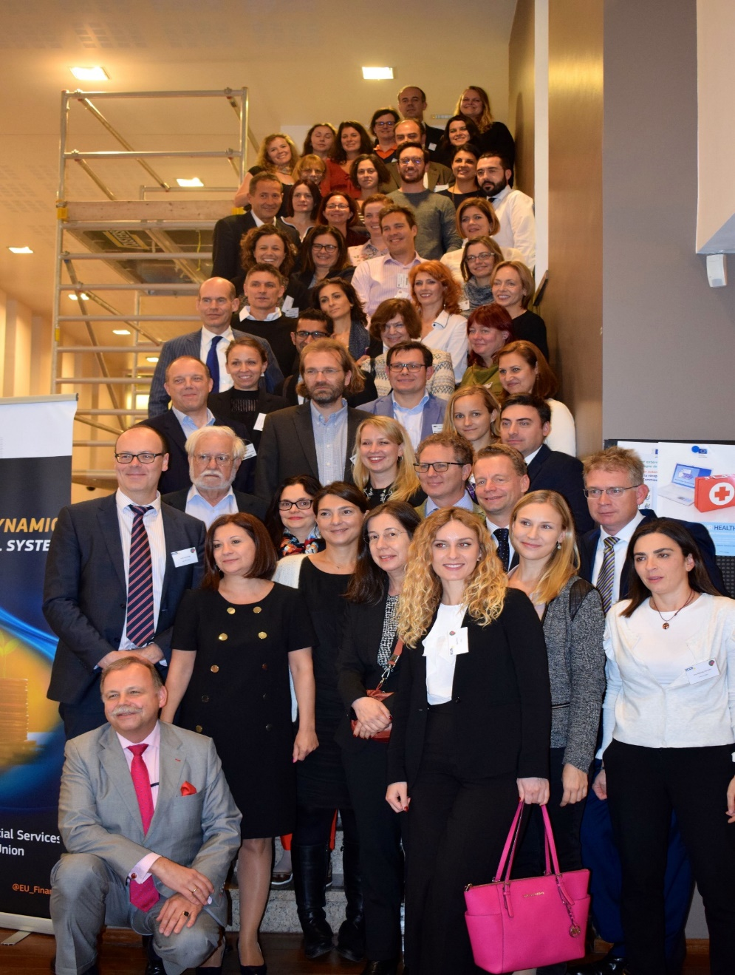

In 2017, ECAS published its first report on the annual trends in obstacles to free movement based on YEA enquiries from citizens. The report was presented at ECAS’ conference ‘Free Movement of Persons in the EU: A Loved and Feared Reality’ in Brussels on 12 April 2017.

Performance in 2017
The YEA team of 61legal experts replied to 19,042 enquiries.
The quality of the service has been maintained at a high level - more than 95% of the controlled cases fulfilled all the quality assurance criteria and 93% of all replies were provided within the deadline.

Nature of the Enquiries
In 2017, YEA again received more enquiries reflecting real problems than just requests for information. This is true for all topics and all categories of citizens. Citizens face obstacles not only from national administrations but also from private entities. A certain proportion of citizens are well informed but unable to find any remedy to their situation.

Social security is still the largest topic and remains stable at 24%. The proportion of enquiries about entry procedures and residence are also stable. We received more questions related to business, especially enquiries linked to taxes and financial services.

Enquiries were received from all 28 EU countries, as well as from Norwegian, Icelandic, and third country nationals who are family members of an EU citizen. YEA received more enquiries from third country nationals, which in 2017 became the most represented group.

The enquiries concerned all 28 Member States, and Norway, Iceland and Liechtenstein. 15% of enquiries were about the United Kingdom, which is partly due to Brexit, but also to the significant number of third country nationals who are family members of an EU citizen, already reside in the EU and would like to move together to the UK.

Outreach Activities
12 YEA experts participated in 9 outreach activities in Belgium, Bulgaria, France, Croatia, Cyprus, Germany, Greece, Ireland, Italy, Sweden and the United Kingdom. The number of participants varied significantly according to the type of event, but, based on the feedback reports, the number of persons reached may have exceeded 2,000. The events fall into 4 categories: network meetings, general public events, consultation days and Facebook chats with citizens.

EU Legal Updates
The Management Team ensures that the experts are kept up-to-date with new legislation and case-law by providing them with a monthly newsletter entitled “EU Law Update”. This newsletter is tailored to the continuously evolving information needs of the experts. It includes the latest news from the EU, information on recent infringement procedures undertaken by the European Commission and an analysis of the latest Court of Justice cases relating to areas dealt with by experts in their enquiries.

Feedback Reports
At the request of the European Commission, ECAS provides four feedback reports to the Commission per year. These reports include details of the cases handled by YEA experts and a policy analysis of the topics covered in the enquiries.

YEA training seminars
In cooperation with the European Commission, ECAS organises a training seminar for all the experts once a year. On 12 and 13 October, the Your Europe Advice annual training seminar took place in Brussels, with 56 experts in attendance. The seminar was launched in the evening of 11 October, with a cocktail party organised at ECAS’ premises, featuring Ms Beatriz Becerra, Member of the European Parliament and Rapporteur on the EU Citizenship Report 2017, as a special guest.
This year, the experts were trained on the latest legislative updates and developments in areas such as residence documents under free movement rules, the Schengen border rules, social security, VAT, geo-blocking and the freedom of establishment.

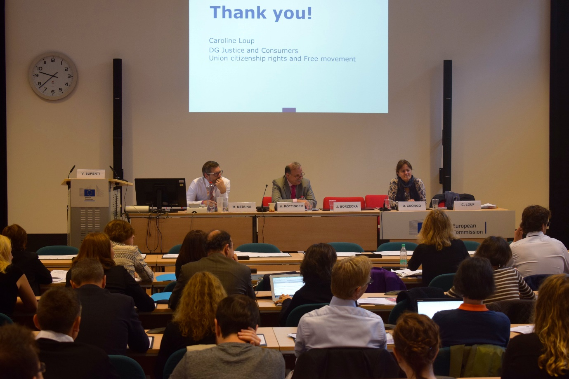

Your Europe Web Portal Assistance
The Your Europe Portal is an EU website designed to provide comprehensive first-stop information and signposting to assist citizens and businesses in understanding, exercising and enforcing their rights and entitlements throughout the European Union under EU law. In 2017, ECAS contributed to updates of the portal concerning companies’ vehicles section, definitions of residence in the different legal areas with references to the respective legal acts and FAQs on Brexit.

Your Europe Chats on Business in the EU and Recognition of professional qualifications
In 2017, YEA experts took part in two online chats hosted on the Your Europe Facebook page. On 23 January, six YEA experts provided online replies to 76 questions on Business / VAT and e-commerce. This chat was followed by 400 users of the platform. On 9 October, YEA experts replied to over 92 questions on professional qualifications and practising a profession in another EU country, with 1,800 persons following the chat.
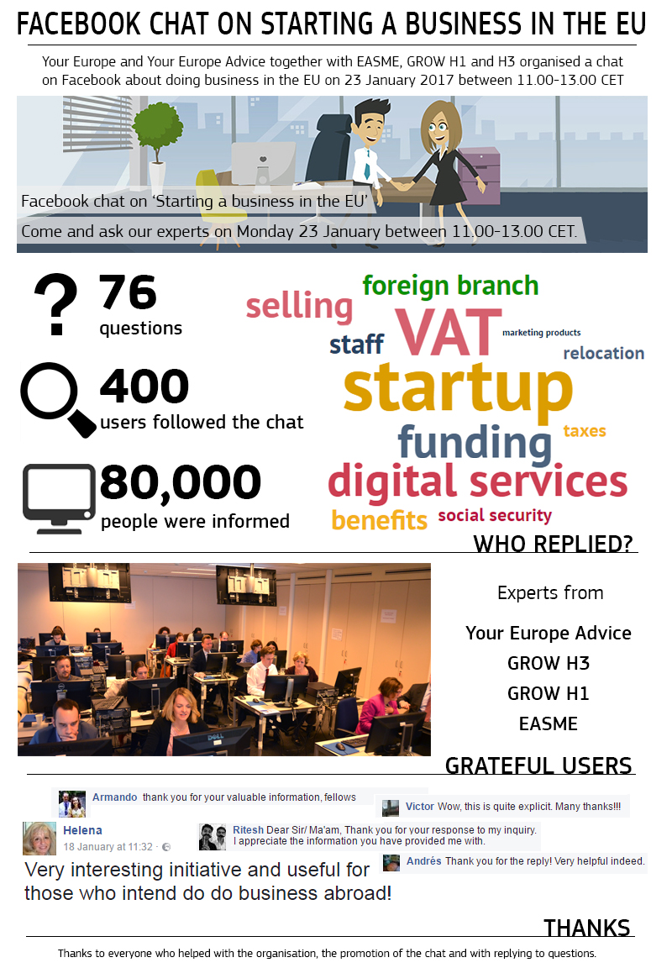
Webinar
On 7 December 2017, ECAS organised a Webinar on VAT for the YEA experts with Mr Timothy Hayes, a VAT expert from DG TAXAUD.

EU Rights Clinic
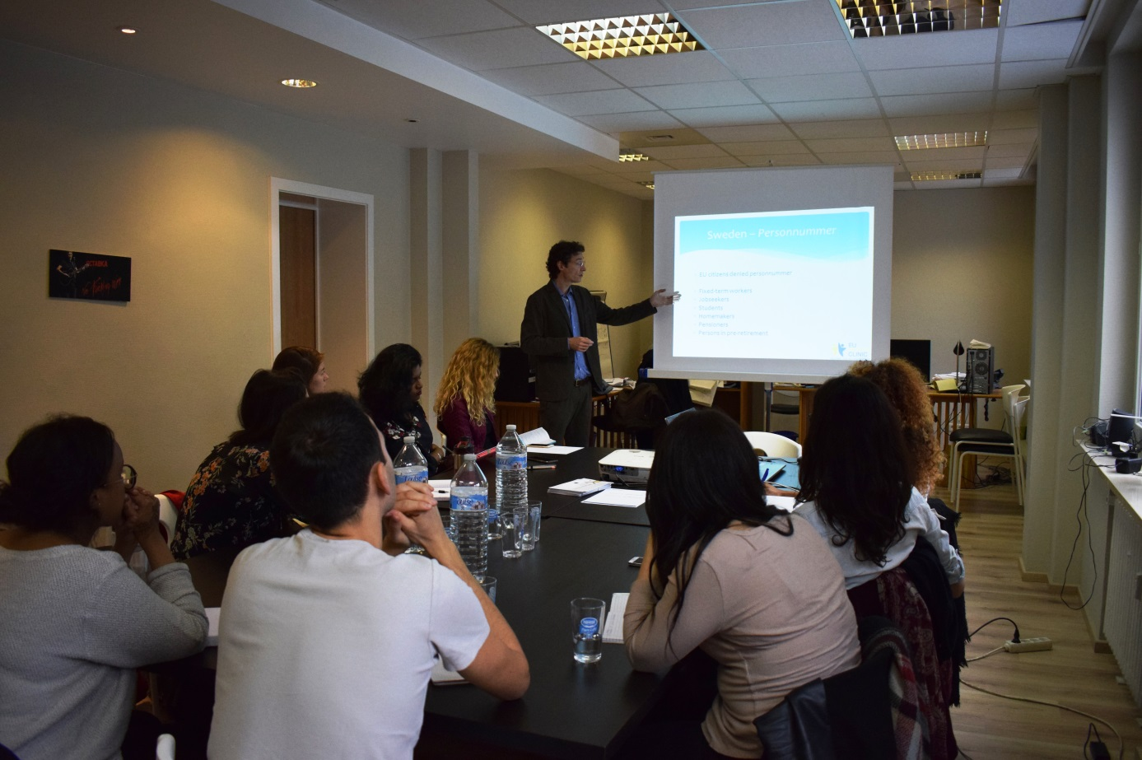

In 2017, the EU Rights Clinic continued to provide problem-solving services in difficult cases involving migrants and advocate for the implementation of concrete and adequate measures at EU level and in Member States to overcome visible and hidden barriers to European citizenship.

Between January 2013 and December 2017, the EU Rights Clinic handled over 538 cases involivng 640 individual clients and 4 NGO clients.

The number of cases handled by year:

The origins of the clients were the following:

Between January 2013 and December 2017, the EU Rights Clinic successfully closed 207 cases (excluding cases referred to other services):

Outcomes by year:

The institutions being dealt with on behalf of the clients were:

The following chart shows the nature of the problems dealt with by the EU Rights Clinic. In 2017, most of the cases concerned residence issues.

In 2017, the EU Rights Clinic continued its cooperation with the Brussels Helpdesk, which is an entity that provides free legal advice and legal action for mobile EU citizens who are exercising their freedom of movement in Belgium and who have been issued with an expulsion order from the Belgian authorities.

Citizen Brexit Observatory
The European Citizen Action Service, University of Sheffield School of Law and Law Centres Network joined forces to create the Citizen Brexit Observatory in order to support the fair treatment of EU citizens living the UK and UK citizens living in the other countries of the EU.

As part of the partnership, an internship programme was launched that involves the hosting of two students at ECAS’ offices in Brussels and the production of research to support public interest issues in the legal and policy debate on the changing relations between the UK and the EU.

The main idea behind the Observatory is to produce and disseminate evidence-based information to support and advocate for a citizen-friendly outcome of the Brexit negotiations. In addition, the CBO offers direct support to EU citizens through the association with Law Centres Network.

The CBO was officially launched at the closing event of the project 5 Takeaways on Brexit: Outlining Possible Scenarios for a New UK-EU Relationship and their Impact on Citizens on 20 June 2017.

Projects

5 Takeaways on Brexit: Outlining Possible Scenarios for a New UK-EU Relationship and their Impact on Citizens
ECAS joined efforts with three partners – New Europeans (UK), the European Disability Forum (BE) and the EU Rights Clinic – to produce a thorough and objective analysis of how citizens’ rights will be impacted under different Brexit scenarios. The project was funded by Joseph Rowntree Charitable Trust.

The study defined five possible scenarios of UK-EU relations following Britain’s exit from the European Union (EU) and fulfilled the project’s three-fold objective, which was to:
- Increase awareness about the different options and their implications for the estimated 1.2 million UK citizens residing in another EU country and the 3.3 million citizens born in another EU country who now reside in the UK;
- Inform associations working directly with citizens about the likely impact of Brexit under the different scenarios to enable them to help the affected citizens to better assert their rights;
- Campaign and advocate for the best possible policy outcome for citizens.

The study and its findings were widely disseminated and shared with a wide variety of stakeholders across Europe. A special effort was made to reach decision-makers in the EU27. It was presented and discussed at a meeting between ECAS’ Director, Assya Kavrakova, and the project coordinator, Marta Pont, and the EU’s Chief negotiator, Mr Barnier, and a member of his team.

In the UK, The New Europeans gave oral evidence to the Exiting the EU Select Committee in January 2017 and took part in the Mass Lobby of Parliament on 20 February, organised by New Europeans and the3million, where participants used the models defined by the study. New Europeans incorporated information from the unpublished report in its submission to the Select Committee, which took evidence throughout January and February.

Both the New Europeans and ECAS took part as speakers in the London Assembly Briefing on July 19. The event featured expert speakers giving evidence to the London Assembly’s EU Exit Working Group on access to advice and support for EU citizens in the UK. The findings were submitted as a report to the Mayor of London.

The following dissemination events were also organised as part of the project:
- 20 March 2017: Session at the All-Party Parliamentary Group on Brexit and on Freedom of Movement
- 20 March 2017: National workshop in London focused on the impact of Brexit on the rights of disabled people (Venue: Resource for London)
- 28 March 2017: National workshop in Belfast (Venue: Queen’s University)
- 25 April 2017 : National workshop in Gibraltar
- 20 June 2017: Final conference in Brussels: Brexit and Citizens’ Rights: Where Do We Go From Here?
In addition to the activities initially planned in the framework of the project, a survey of citizens’ concerns was carried out and a Citizen Brexit Observatory was launched.
Finally, ECAS also launched a Brexit Working Group, which it also chairs, within Civil Society Europe, an umbrella organisation that brings together 28 European networks of civil society organisations (CSO) working towards regenerating the European project around the shared values of equality, solidarity, inclusiveness and democracy.

One Stop Shop for Political Participation of Mobile EU Citizens
Funded by the European Commission and led by the Migration Policy Group (MPG), this project focused on informing and encouraging EU mobile citizens to take up rights and opportunities to participate in their host EU country’s civic and political life. Moreover, it aimed to develop and promote the exchange and dissemination of innovative community methods based on the best available research and practices. In addition, the project raised awareness of the reasons, procedural and practical obstacles, and interests for mobile EU citizens to use these rights and opportunities.

In 2017, ECAS’ activities were aimed at collecting and analysing replies to a survey entitled “Obstacles to political rights of EU mobile citizens”. The survey was launched by ECAS on 29 March 2017 and closed on 8 December 2017. It was promoted by ECAS and the project partners through social media and the organisation of one-stop-shop events in Belgium, Ireland and UK.

The aim of the survey was to gather the key concerns of mobile EU citizens related to the exercise of their EU political rights with a focus on the right to vote in local and European elections and civic participation in their host country. The findings shed light on the drivers and obstacles to political participation of EU mobile citizens and should provide feedback to decision-makers, offering leads to the organisers of future elections on how to increase the turnout of EU citizens living in EU countries other than their own. Respondents were asked about their perception of political and civic engagement in their host country and their country of origin in order to examine reasons for disengagement. The importance placed on active political engagement as a factor of change and improvement of status was also studied. The role of local authorities in facilitating active political and civic engagement was also examined and suggestions for improvements were solicited from the respondents.

The main findings of the survey were as follows:
- Mobile EU citizens experience difficulties in registering to vote, do not vote because voting represents an administrative burden and/or experience problems with local authorities based on their origin;
- Mobile EU citizens vote less outside their country of origin and the majority are politically and civically inactive;
- The opportunity to improve the situation of one’s community is essential to stimulating political participation, according to the respondents. However, political engagement is not perceived as decisive for the improvement of one’s status in the host country;
- Discrimination and other difficulties experienced in the host countries also motivate political and civic engagement;
- Many respondents consider that the right to participate in national referenda as well as legislative, parliamentary and presidential elections, under the same conditions as nationals of the host country, would greatly stimulate their involvement in political and civic life;
- Expat-friendly events are considered by a large majority of citizens as crucial to increasing political and civic activity of mobile EU citizens. However, most citizens do not think that the local authorities are doing enough to promote active citizenship of expats.

Main obstacles to increased political and civic participation:
- The fact that mobile EU citizens cannot vote in national elections and referenda;
- Language barriers;
- Not understanding the political system of the country;
- Temporary residence attitude of mobile EU citizens.

Suggestions for local authorities to increase participation:
- Organisation of targeted events for mobile EU citizens;
- Better dissemination of information on the political system, processes and electoral procedures;
- Langauge classes and opportunities to learn more about the culture of the country organised by the local authorities and the the establishment of dedicated units within local authorities to engage non-nationals;
- Creation of committees of representatives from the expat community inside the municipalities.

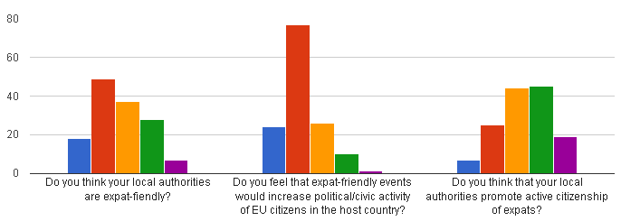
Member of a political party Voting Standing as a candidate in elections
Participating in demonstrations Civic activity I am not politically or civically active
Other
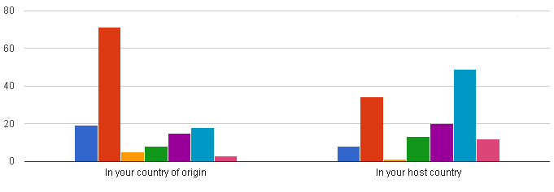

ACT for Free Movement
This project is supported by the European Programme for Integration and Migration (EPIM), a collaborative initiative of the Network of European Foundations, and is led by ECAS in partnership with: European Alternatives (EA), UK, Gothenburg Rescue Mission (GRM), Sweden, EU Rights Clinic (EURC), Belgium, Krytyka Polityczna (KP), Poland, and the Good Lobby (GL), Belgium.

ACT for Free Movement aims to establish permanent direct advocacy in Brussels and provide support, resources and training to citizens throughout Europe to take action to counter the trend towards a restrictive interpretation of the EU Citizenship Directive (2004/38/EC). Its final objective is to increase the extent to which EU citizens can effectively secure access to, and are aware of, their rights and build public awareness and political support for mobile citizens’ rights. To achieve this, a multilevel strategy was deployed, which entails:
- Research to identify specific problems and to define good practices in free movement of EU citizens;
- EU-level advocacy through complaints to the European Commission and petitions to the European Parliament as well as submissions in the REFIT platform;
- Training of free movement activists during workshops in Poland, Italy, Spain, Sweden and the UK, and providing support to their grassroots campaigns on mobile citizens’ rights.
The project began in April 2017 and will finish in October 2018.

Research
On the basis of Your Europe Advice cases in the period from 2015 until 2017, ECAS has identified the problems faced by EU mobile citizens in the EU28 and will produce a study in early 2018. The findings should inform any new Communication of the Commission on the implementation of the Citizenship Directive (2004/38/EC) and the next DG Justice Citizenship Report.
In parallel, ECAS has started identifying good practices in the implementation of the EU Citizenship Directive at national level. The best practices will feed into an interactive guide (accessible both to EU mobile citizens but also EU and national decision-makers). The idea is to look for examples of administrative measures taken by EUMS that successfully addressed identifiable problems with the application of the Directive.

Advocacy and complaints
ECAS has actively advocated before the European institutions and the EUMS to build political will to implement the Citizenship Directive to the maximum, rather than the minimum. This was achieved primarily through the adoption of a submission by ECAS in the Regulatory Fitness and Performance (REFIT) platform.
On 23 November 2017, Members of the REFIT Platform adopted an opinion recommending the Commission issue a new Communication on Directive 2004/38/EC, which governs the free movement of persons within the EU, with the purpose of overcoming the existing loopholes in the Directive, providing up-to-date guidelines to Member States on its implementation, as well as reflecting the recent and not codified ECJ judgments on free movement rights.

The opinion is the result of a submission by Assya Kavrakova, member of the Refit Platform Stakeholder Group, who identified, in the framework of the research accomplished in the project and on the basis of the enquiries received in the last three years by Your Europe Advice, certain grey areas in the Citizenship Directive that require further clarification in order to allow EU mobile citizens to fully enjoy and exercise their free movement rights.

In particular, the main challenges faced by EU mobile citizens and recognised by the Members of the REFIT platform concern the satisfaction of the “comprehensive sickness insurance” condition, the concept of “sufficient resource”, residence rights of EU citizens and their third-country family members, the application of the Surinder Singh rules, as well as the treatment of dual nationals and dependent non-EU children.

The opinion was supported by the majority of the REFIT Government Group, who agreed that a new Communication on the Citizenship Directive “would be beneficial to citizens, public administration and SOLVIT centres, provided it is based on and limited to the rulings of the Court of Justice”. The Commission is expected respond to the opinion in early 2018 and report on its progress in the ‘Refit Scoreboard’.

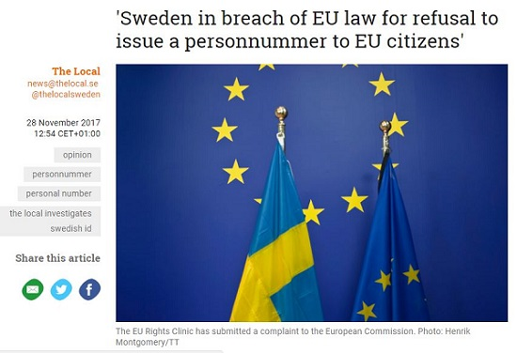
In cooperation with Crossroads Göteborg (Göteborgs Stadsmissionen), the EU Rights Clinic and ECAS submitted a complaint to the EC related to a breach of Free Movement Rules by Sweden. The complaint was submitted on behalf of 285 individuals who requested to remain anonymous. In conjunction with the complaint, the EU Rights Clinic also submitted a petition to the European Parliament. The complaint related to the refusal of the Swedish tax authorities (Skatteverket) to issue a personal tax identification number (“personnummer”) to EU citizens and their family members who are living in Sweden, thereby affecting their ability to engage in everyday life in Sweden. It also covers Sweden’s restrictive administrative policy on comprehensive sickness assurance.

Under EU law, EU citizens should be considered genuinely resident in Sweden after having lived in Sweden for only three months. While EU law does allow Sweden to require EU citizens who are not in employment to hold comprehensive sickness insurance for themselves and their family members, the rules must be applied in a proportionate way and must give due regard to all forms of healthcare coverage. The Swedish rules are in breach of Article 45 Charter of Fundamental Rights, Articles 20, 21 and 45 of the Treaty on the Functioning of the European Union, Articles 24 and 25 of Directive 2004/38, as well as related ECJ case law.

Training of free movement activists
On 18-20 September, the ACT for Free Movement training series kicked off in Warsaw, with 17 free movement activists from across Europe joining the European Alternatives, ECAS and Krytyka Polityczna for three days of intensive training on EU citizenship, free movement rights, rights’ enforcement and campaigning.
Activists from universities, NGOs and the legal profession all took part in the training – the first in a series of four workshops – to address the rise in restrictions to, and infringements of, free movement rights across Europe.
The participants were given a comprehensive overview of EU citizenship and free movement rights, were informed about the mechanisms for defending those rights, from the local to the transnational level, and experimented with participatory approaches to campaigning for EU citizens’ rights.
They also shared their own visions of free movement, and the current challenges to those rights, with Polish activists and migrant rights’ organisations, from the rise in nationalism and the far-right to the development of positive narratives for free movement in Europe.

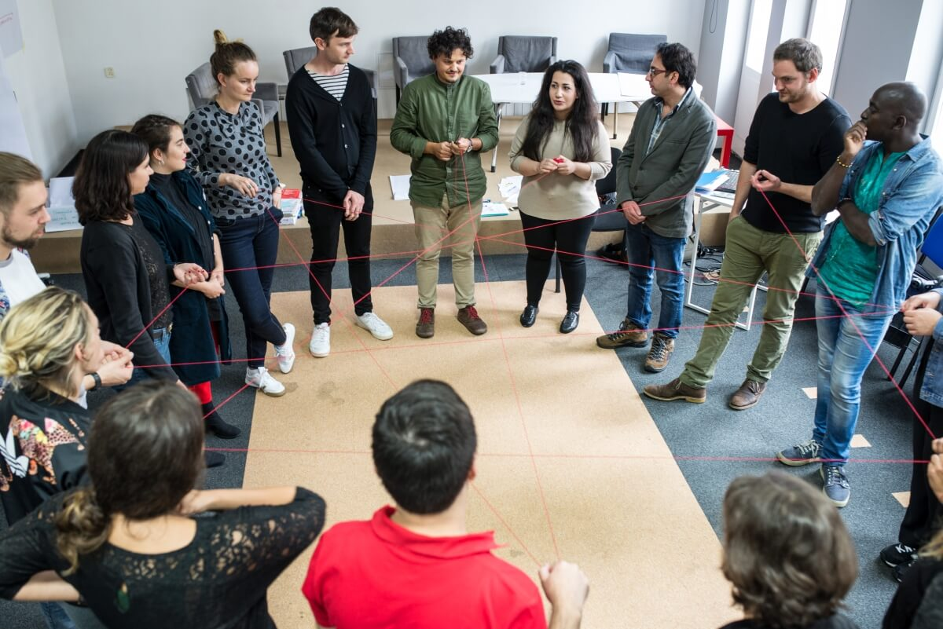
The second training took place in Madrid from 25-29 October at the European Alternatives’ TRANSEUROPA Festival. The activists continued to develop their campaigns and exchange ideas on how to strengthen free movement rights in Europe and elaborate creative narratives and innovative actions for their enforcement.

Prior to the training, the participants defined the premises of their campaigning projects that will be implemented in early 2018 through a small sub-granting scheme. ECAS’s team, composed of Elisa Lironi and Assya Kavrakova, provided feedback sessions and tailor-made advice to the participants on their campaigning ideas. This included the definition of the objectives, identification the target groups and maximising dissemination by using off-line and on-line techniques. Given the modest funding available for the campaigns, the participants were given advice on how to maximise their impact with limited resources, including upscaling national campaigns to the EU level and finding additional support for dissemination.

Events

Brexit and Citizens’ Rights in Northern Ireland
As the only UK region sharing a direct border with an EU country and given its close links with Ireland, Northern Ireland and its citizens are expected to be heavily impacted by Brexit. Brexit is not only expected to limit the rights of people to live, reside and work elsewhere in Europe, but could also compromise the Common Travel Area (CTA) between the UK and Ireland and the Belfast Agreement underpinning the peace process. Northern Ireland is also expected to be one of the regions most affected by the loss of EU funds. These are some of the issues that were addressed during our workshop in Belfast on 28 March 2017.

The workshop, organised by the European Citizen Action Service (ECAS) and the Centre for Cross Border Studies (CCBS), took place at Queen’s University in Belfast and was attended by 40 participants. Parts of the workshop were broadcast live and followed by over 300 viewers online. It consisted of a panel of four speakers, who analysed the implications of Brexit for citizens’ rights, with an emphasis on the special considerations for Northern Ireland as a special region which will share a direct border with an EU country after Brexit. The panel was followed by small group discussions among the participants about their concerns and suggestions concerning the Brexit process and future arrangements with the EU.
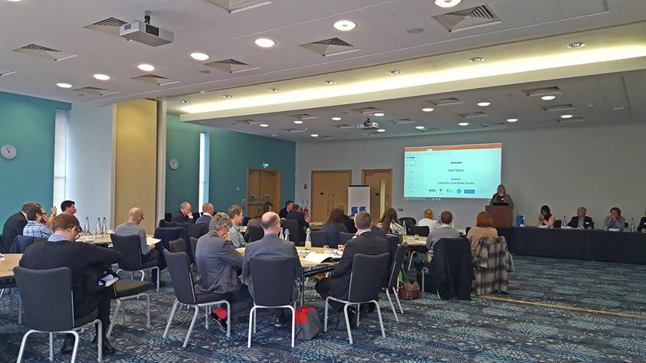

Free Movement of Persons in the EU: A Loved and Feared Reality

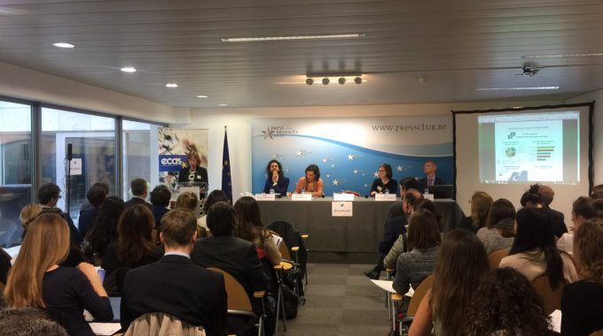
In the 60 years since the concept of free movement of persons was first established in the Treaty of Rome, it has evolved to become the cornerstone of EU citizenship, granting EU citizens the right to move and reside freely within the territory of the member states. Today, despite the various challenges it faces, it remains the most cherished right of EU citizens.
On the occasion of the 60th anniversary of the Treaty of Rome, the conference was organised to address the current obstacles to free movement and strategies for restoring trust in this fundamental EU right and had two explicit aims:
- Identify the current challenges to the fundamental EU right of free movement; and
- Explore viable strategies and actions for restoring trust in, and recognition of, this most notable achievement of the European project for citizens.
The conference featured keynote addresses by MEPs Jill Evans and Jean Lambert from the Greens/EFA group, and had two panels of representatives from EU institutions and civil society, as well as experts in EU and national law.
It was attended by over 100 participants, received over 150 views online and was featured, along with the Your Europe Advice 2016 Annual Trends Report that was presented at the conference, in a number of news outlets, including EUobserver, The Independent and Euractiv.

Brexit and Citizens’ Rights: The Case of Gibraltar
As a special British overseas territory sharing a land border with an EU country, Gibraltar’s economy and people are expected to suffer significantly from Brexit, in spite of the fact that its population of 32,000 inhabitants voted overwhelmingly to stay in the EU in the UK’s referendum.

With 12,000 European citizens crossing the border from Spain every day to work in Gibraltar, preserving a free flowing border post-Brexit with its neighbour Spain will be of utmost importance for Gibraltar’s economy, which is greatly dependent on the cross-border workers who hold 40% of the total jobs on the Rock. A free flowing border is also crucial for the tourist sector, as the majority of the 10 million tourists who visit Gibraltar every year reach the Rock by land. A fluid border will be equally important for the economy of Andalucía, since Gibraltar is the second largest employer for the whole Spanish region. The status of Gibraltar’s airport and its access to the EU single airspace will also be an important issue in the withdrawal agreement, as will the participation of Gibraltar in the future trade agreements that the UK will strike with third countries. These are some of the issues that were addressed during our conference in Gibraltar on 25 April 2017.
The conference, organised by the European Citizen Action Service (ECAS) and Citizens Advice International (CAI), with the support of the Government of Gibraltar and Hassans International Law Firm, took place at the University of Gibraltar and was attended by 120 participants. The conference was also broadcast live and followed by over 70 viewers online, and was followed with great interest by the local media.
This event was organised in the framework of the project ‘Brexit Takeaways’, which aims to raise awareness among citizens of the possible impact of different Brexit scenarios on their rights and advocate for the best possible deal for citizens.
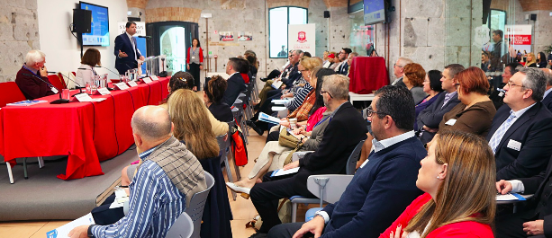

Brexit and Citizens’ Rights: Where Do We Go From Here?
Almost a year on from the EU referendum in the UK, it is still unclear what will happen to the rights of the estimated 3.2 million Europeans living in the UK and the 1.2 million Britons living elsewhere in Europe.

In her article triggering Article 50 TEU on 29th of March, Theresa May make the interests of citizens a priority in the negotiations and called for an early agreement about their rights. The European Council guidelines for Brexit negotiations on 29 April, as well as in the European Parliament’s red lines on Brexit negotiations, also made this a priority. However, none of the parties has yet elaborated what this will mean or what will be done in practice.
Based on our Brexit study and final event of our Brexit project, the Brexit roundtable in Brussels brought together key figures from civil society and politics to discuss the issue of citizens’ rights after Brexit, including a keynote speech by Stefaan De Rynck from the European Commission’s Article 50 Taskforce.
It was also the launch event for the Citizen Brexit Observatory, an initiative to support the fair treatment of EU citizens in the UK and UK citizens in the EU, and featured the presentation of the findings of our Brexit survey.
The event was attended by over 120 people in person and received over 380 views online.
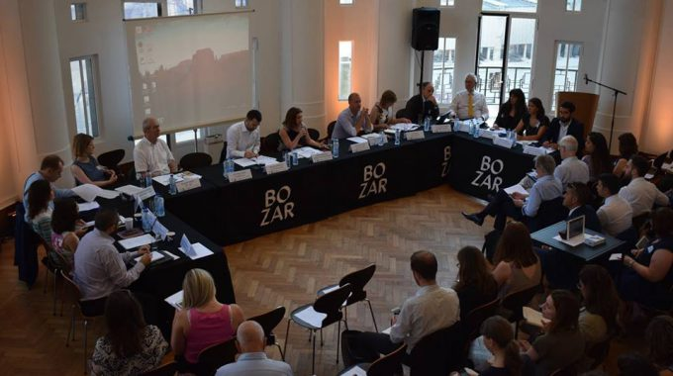

Research Studies

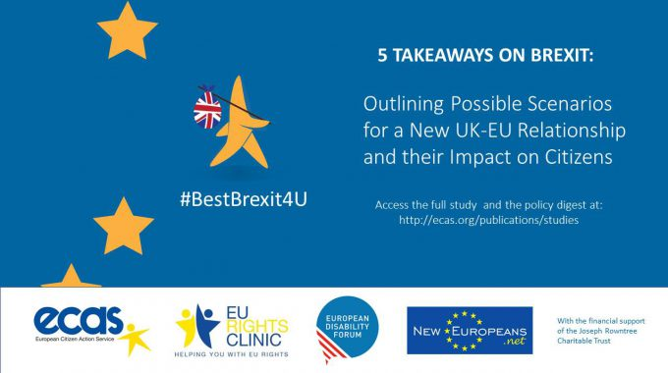

5 Takeaways on Brexit: Study on Brexit and Citizens’ Rights
With more than 3 million EU citizens resident in the UK and over 1 million UK citizens residing in other Member States, whose rights in those countries will be directly affected, there is a great deal of uncertainty about their future legal status after Brexit.

As part of its mission to empower citizens to exercise their rights in the EU, ECAS, in partnership with the EU Rights Clinic, the European Disability Forum and the New Europeans, considered the impact of Brexit on citizens’ rights under different scenarios compared to the rights that citizens currently enjoy whilst the UK is a full member of the EU. The study analyses, in addition, the possible repercussions of Brexit for the access of UK-based entities to EU funding streams.

The purpose of the study was to provide citizens with a comprehensive analysis of the potential consequences of Brexit for citizens’ rights and to enable citizens and civil society to advocate for the best possible Brexit for them.

The study was produced by a team comprised of ECAS Director, Assya Kavrakova, ECAS Membership and Outreach Manager, Marta Pont, and Professor Anthony Valcke at the University of Kent in Brussels and Supervising Solicitor at the EU Rights Clinic, supported by intern Connor Brown from the University of Sheffield. New Europeans and the European Disability Forum also contributed, respectively, to the analysis on voting rights and on non-discrimination rights.

Brexit and the European Arrest Warrant: How Will Change Affect the Interests of Citizens?
This study, highlights the interests of citizens in the area of Freedom, Security and Justice and canvases possible policy options post-Brexit to provide information and guidance for individuals, bodies and organisations working with those citizens who may find themselves affected by such changes. The UK’s continued participation in the European Arrest Warrant (EAW), a key instrument of cooperation among EU Member States in the enforcement of justice and prosecution of crime on a cross-border basis, is uncertain and has implications for the rights of citizens.

In particular, the study focuses on two aspects of the functioning of the EAW that may have significant consequences for citizens. The first point concentrates on the surrender procedure of accused or convicted persons and specifically provides an assessment of implications for the pre-trial detention stage. The second aspect focuses on extradition conditions and guarantees between the UK and EU Member States.
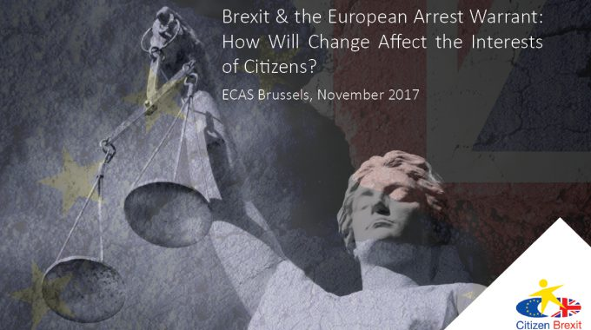
Study: http://ecas.org/european-arrest-warrant-brexit/

Brexit and Loss of EU Citizenship: Cases, Options, Perceptions
This study explores the options available to ‘static’ UK nationals through an analysis of various policy options, including ‘Associate Citizenship’ and decoupling EU citizenship from nationality, and interviews with experts, stakeholders and citizens.

This group faces a loss of political rights, such as the right to participate in local and EU elections and to participate in a European Citizens’ Initiative, but will also lose the choice of whether to become mobile. UK nationals under the age of 18, who were unable to vote in the referendum and are unlikely to have had the opportunity to exercise their European citizenship rights, are particularly affected, and these rights are set to be taken away from them without their participation in the decision.
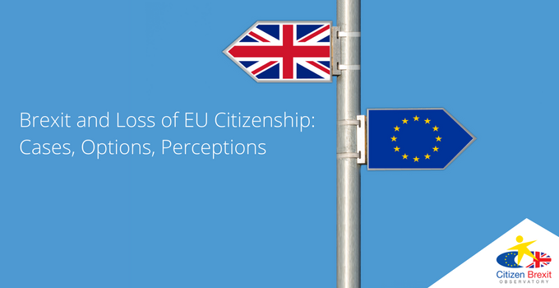
Study: http://ecas.org/brexit-loss-eu-citizenship-study/

Policy Positions

EU Citizenship Report 2017: More Action Needed to Safeguard Freedom of Movement
On 24 January, the European Commission published its 2017 EU Citizenship Report, which takes stock of the achievements of the three years since the last report was issued and puts forward new actions to further improve the exercise of EU rights by citizens and businesses. While the new edition definitely brings a qualitative leap compared to the previous report, we believe the current situation demands more than a “business-as-usual” approach.

Raising awareness of EU rights

ECAS welcomes, in particular, the Commission’s proposed actions to address the lack of awareness among citizens of the rights and benefits that come with EU citizenship, as well as some measures to improve the exercise of free movement rights. However, the proposed actions essentially concentrate on raising public awareness of the rights associated with EU citizenship, but do not address the notable deterioration that some of these rights – in particular freedom of movement – have undergone in recent years. This situation calls for bolder measures to protect them beyond promotion and awareness-raising.

Free movement constantly challenged
The right to free of movement, which has been enshrined as a fundamental freedom in EU Law since 1957 and is still the most cherished right by European citizens^{[1]}, has been constantly challenged in recent years, as reflected in the enquiries received by the Your Europe Advice (YEA)^{[2]} service. Enquires submitted by EU mobile citizens who exercise their right to free movement and encounter difficulties increased by more than 30% in the period 2012 – 2015 (from 16,761 in 2012 to 22,137 in 2015). In 2015, for the first time, “entry procedures” featured as the second most problematic issue across the EU after “social security” and followed by “residence”.
Social security remains the top area of concern for EU citizens who exercise their free movement rights, with almost 30% of the enquiries handled every year by YEA legal experts touching exclusively upon this area. ECAS welcomed the Commission’s proposal of 13 December 2016 to reform current EU legislation on social security coordination (i.e. EU Regulations 883/2004 and 987/2009) and hopes that the proposed new rules will not be watered down in the negotiations with the Parliament and the Council.

Time to review the “Citizenship Directive”
Considering, however, the “new phenomenon” witnessed in recent years of an increasing number of enquiries from citizens who face obstacles to “entry” and “residence”, ECAS believes that special attention should also be paid to Directive 2004/38/EC as the most important legislative instrument governing free movement of people within the EU. The so-called “Citizenship Directive” has been in force for more than ten years and has been the subject of numerous judgments of the Court of Justice of the EU, while its implementation remains problematic. Some of the problems are due to gaps in the very text of the Directive, such as the visa exemption enjoyed by family members who hold a residence card^{[3]}, which is not explicitly extended to family members who hold a permanent residence card.^{[4]} Others stem from the fact that directives are not capable of having a so-called ‘horizontal direct effect’, which means they cannot be relied upon by citizens making claims against private parties.
Moreover, cases handled by our EU Rights Clinic have informed us that, in a number of countries, EU mobile citizens persistently experience specific problems. The UK Home Office refuses, for instance, to bestow residence rights on EU citizens who do not work (such as students or homemakers) if they are not in possession of private healthcare insurance. This situation could affect over 1 million EU citizens in the UK. In Sweden, tax authorities refuse to issue personal identification numbers (“personnummer”) to EU citizens and their family members. In Belgium, in cases where an expulsion order has been issued, the judicial appeal system fails to allow EU citizens to secure continued residence and safeguard their acquired rights under the Citizenship Directive. In Germany, there are excessive delays by the relevant authorities (“Familienkasse”) in processing claims for family benefit (“Kindergeld”) to which EU workers in Germany are entitled.

ECAS Response to the Public Consultation on EU Social Security Coordination
In reponse to the European Commission’s public consultation on EU social security coordination on the revision of Regulations (EC) No 883/2004 and (EC) No 987/2009, which closed on 7 October 2015, ECAS made the following recommendations:
Recommendation 1: A new provision should be inserted into Regulation 883/2004 that explicitly provides for the right of EU citizens who are not working to be able to affiliate with the public healthcare system of the Member State where they reside under the same conditions that apply to nationals.
Recommendation 2: A new provision should be inserted into Regulation 883/2004 that explicitly provides for the exportability of long-term benefits.
Recommendation 3: The period for the exportability of Article 64(1)(c) of Regulation 883/2004 should be increased to six months (if not longer) and allow the competent services or institutions to extend that period by another six months (if not longer).
Recommendation 4: Reform of the rules on family benefits must give due consideration to the established case law of the Court of Justice on this point in order to ensure full respect for the principle of equal treatment.
Recommendation 5: An official table of correspondence should be published that identifies old E Forms and the corresponding Portable Documents and Structured Electronic Documents.
Recommendation 6: Article 6 of Regulation 987/2009 needs to be bolstered, so it also covers employees wrongly affiliated to a Member State in breach of the rules on applicable law, irrespective of whether Member State disagree under whose system the worker should be affiliated. In such cases, the institution with which the worker was incorrectly affiliated should be under a legal obligation to transfer incorrectly paid contributions to the competent institution within three months of the problem being identified.
Recommendation 7: Regulations 883/2004 and 987/2009 need to provide additional safeguards for employees who have become unemployed following insolvency and whose employers did not make compulsory social security contributions.
Recommendation 8: An obligation on Member States to collate statistical information on the number of EU citizens (and EEA nationals) claiming benefits should be inserted into Regulations 883/2004 or 987/2009. Such data should be disaggregated by gender, age and type of benefit. There should be an obligation to make this information public.
Recommendation 9: Consideration should be given to aligning the conditions under which a posting may take place under Article 1 so that these are aligned to the rules for the posting of workers under the EU social security rules. The inclusion of an obligation to publish statistics on posted workers should also be considered.

ECAS Welcomes the EP’s Draft Position on the Europe for Citizens Programme

ECAS participated in the rapporteur’s consultations with civil society
On 17 October, MEP María Teresa Barbat, who is preparing the European Parliament’s position on the mid-term review of the Europe for Citizens programme, submitted a draft report on the programme. This draft report draws on the input provided by a number of stakeholders and civil society representatives who have experience with this programme. This included ECAS, who conducted a consultation among its members and partners from July to September 2016. Read the findings of this consultation here.

In her report, the EP rapporteur put forward recommendations which are largely in line with ECAS’ suggestions, based on the findings of our consultation.

ECAS’ Position on More or Less Europe – What the Commission’s White Paper Means for Citizens
The Commission’s ‘White Paper on the Future of Europe’ outlined five scenarios for a ‘new chapter’ of European union for the EU27, but failed to answer the key question – what do citizens want from Europe.
Despite European Commission President Jean-Claude Juncker’s call for “leadership, unity and common resolve” in taking the EU27 forward after Brexit and the White Paper‘s stated aim to “advance our project in the interests of our citizens”, his five scenarios for the future of the EU – ‘carrying on’, ‘nothing but the single market’, ‘those who want more do more’, ‘doing less more efficiently’ and ‘doing much more together’ – reflect the realism of working for a compromise between 27 Member States rather than a true vision of a Europe for its citizens.

ECAS proposal for a citizen-centric scenario
What is missing from the White Paper, and where the substance fails to match the rhetoric, is a sixth, citizen-centric scenario. In the words of MEP Patrick Le Hyaric in a discussion on the White Paper at the European Parliament, “We need to listen to the citizens. Otherwise, we’ll fail to meet the challenge.”

One way of doing this would be to use crowdsourcing to solicit the views of EU citizens. ECAS’ study on crowdsourcing emphasises the value of this tool for engaging the unengaged and reducing the gap between EU decision-makers and citizens. This could, in turn, transform the relationship between them into more of a partnership and address one of the key objectives of the White Paper – to restore trust, build consensus and create a sense of belonging.

As the White Paper states, Europe needs to “speak with one voice”, stand up for “free and progressive trade”, build an “inclusive, competitive, resilient and future-proof” economy, develop social rights to keep pace with “the changing world of work”, reignite trust in free movement and close the gap between promise and delivery. It can only do this with the consent of its citizens.

Press Release: What Do Citizens Want From Brexit? – Free Movement, Healthcare and Non-Discrimination
Restrictions to the right of free movement are the biggest concern for both EU and UK citizens, who value the right to live and work in another EU Member State above all other EU rights, according to the findings of a survey published by ECAS.

Whilst the top concern of both EU and UK respondents related to restrictions to free movement, UK citizens are more afraid of losing their EU citizenship and EU citizens more concerned about an uncertain future, discrimination and xenophobia.

Among the findings of the survey, 96 per cent of UK and 86 per cent of EU respondents felt personally affected by Brexit and a majority of both groups have become more socially and politically engaged after the EU referendum, as well as becoming better informed about the current political situation and more vocal about their rights.

Despite being more politically engaged, however, an increasing number of UK and EU citizens consider themselves to be less aware of their rights than before the referendum. In all, there was a 10 to 15 percentage point decrease in rights awareness among all respondents as a result of the referendum.
Following the presentation of the results of the survey ‘What Do Citizens Want From Brexit?’ at the European Network of Ombudsmen conference in June 2017 by ECAS’ Executive Director Assya Kavrakova, ECAS has featured in the European Network of Ombudsmen’s annual ‘Network in Focus‘ magazine, published on 9 November 2017.

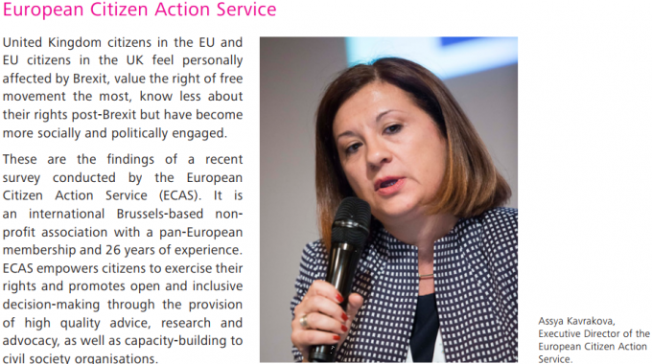

The REFIT Opinion on the Citizenship Directive
The European Commission’s Regulatory Fitness and Performance (REFIT) platform called on the Commission to adopt a new Communication clarifying certain grey areas in Directive 2004/38/EC on residence rights in order to improve and harmonise the implementation of the Citizenship Directive at national level.

On 23 November 2017, Members of the REFIT Platform adopted an opinion recommending the Commission issue a new Communication on Directive 2004/38/EC, which governs the free movement of persons within the EU, with the purpose of overcoming the existing loopholes in the Directive, providing up-to-date guidelines to Member States on its implementation, as well as reflecting the recent and not codified ECJ judgments on free movement rights.

The opinion is the result of a submission by Assya Kavrakova, member of the Refit Platform Stakeholder Group and ECAS’ Executive Director, who identified, in the framework of our Act for Free Movement project and on the basis of the enquiries received in the last three years by Your Europe Advice, certain grey areas in the Citizenship Directive that require further clarification in order to allow EU mobile citizens to fully enjoy and exercise their free movement rights.

In particular, the main challenges faced by EU mobile citizens and recognised by the Members of the REFIT platform concern the satisfaction of the “comprehensive sickness insurance” condition, the concept of “sufficient resource”, residence rights of EU citizens and their third-country family members, the application of the Surinder Singh rules, as well as the treatment of dual nationals and dependent non-EU children.

The opinion was adopted by all members of the Stakeholder group and supported by the majority of the REFIT Government Group, who agreed that a new Communication on the Citizenship Directive “would be beneficial to citizens, public administration and SOLVIT centres, provided it is based on and limited to the rulings of the Court of Justice”.

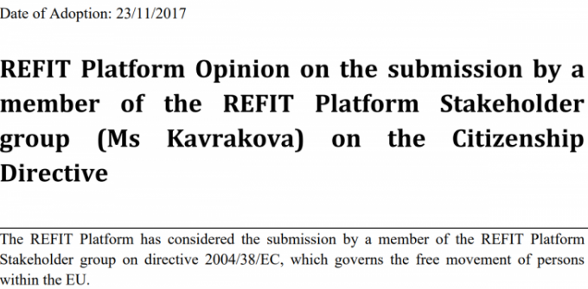

EU Rights Clinic Calls For Rights of Family Members and Carers of EU Citizens to be Safeguarded Post-Brexit
As part of the EU Rights Clinic, ECAS has submitted letters to the European Commission’s Taskforce on Article 50 and the European Parliament’s Brexit Steering Group to express concerns about the protections granted to the rights of EU citizens and their family members and carers living in the UK following the recent agreement reached by the UK and EU to conclude phase 1 of negotiations.

The EU Rights Clinic sought urgent confirmation from the European Commission and European Parliament that the status of the following categories of EU Citizens and family members who currently enjoy rights of residence under EU law:
- family members of EU citizens who have returned home after having resided in another
Member State as recognised by the Court of Justice’s ruling in Case C-370/90 Surinder
Singh and subsequent cases;
- primary carers of the children in education of migrant workers or former migrant workers
under Regulation 492/2011 on the free movement of workers as recognised by the Court
of Justice’s rulings in Case C-480/08 Texeira and Joined Cases C-147/11 Teixeira and
subsequent cases;
- primary carers of Union citizens having a right of residence in the EU citizens’ home
country arising from the Court of Justice’s ruling in Case C-34/09 Ruiz Zambrano and
subsequent cases.

The EU Rights Clinic also sought assurances over the interpretation of “lawful residence” under EU law and that inactive EU citizens will not be required to have held “comprehensive sickness insurance”.

The letters have been submitted on behalf of 34 signatories, including ECAS’ Executive Director Assya Kavrakova, representing various organisations providing legal assistance and advice to EU citizens living in the UK and British nationals living in the the other 27 EU Member States.

ECAS’ contribution to the European Parliament Citizenship Report 2017: Strengthening Citizens’ Rights in a Union of Democratic Change (2017/2069(INI))
ECAS was the only civil society organisation that was consulted in the framework of the preparation of the EP’s Citizenship Report, which was published on 30 November 2017. ECAS shared with the PETI committee the YEA Annual Trends of 2016 as well as its position on the Labour Mobility Package and held a meeting with MEP Beatriz Becerra on 1 June 2017. Its contribution is reflected in item 37. of the report:

“Urges the Member States to guarantee that their national legislation is sufficiently clear and detailed to ensure that the right of free movement of citizens and their families is respected, to proceed with the proper training of the competent national authorities in this respect and to disseminate accurate information to interested parties in a precise manner, and to foster good cooperation and a swift exchange of information with other national administrations, especially where cross-border insurance and retirement pensions are concerned;[…]”

DIGITAL DEMOCRACY Focus Area
ECAS is implementing a Digital Democracy Agenda with the aim being to explore the democratic potential of Information and Communication Technology (ICT) in:
- Reducing the gap between political elites and citizens.
- Transforming the relationship between EU citizens and EU decision-makers into more of a partnership, thus contributing to the creation of an engaged citizenship.
- Enabling the EU to go beyond consultations and structured dialogues with the usual stakeholders to expand the number of contributors to EU policy-making, remove potential barriers to participation that translate into a general feeling of exclusion, and engage groups that are underrepresented.
In 2017, ECAS continued advocating for stronger Digital Democracy in the EU through different activities. In the second and final year of the DEEP-linking Youth project, ECAS produced, with its project partners, two reports for EU policy-makers with recommendations on youth e-participation through ‘social listening’ and recommendations on improving the Erasmus programme by using the Digital Dashboard.

Through the EUCROWD project, ECAS has been present at many national events to have direct conversations with citizens on EU policy-making and e-participation and crowdsourcing mechanisms.

ECAS has also been increasingly invited to numerous events to participate as a speaker, expert or trainer on this topic.

ECAS also continued striving for the improvement of already existing EU participation tools. ECAS produced a new study commissioned by the EESC: ‘EU Public Consultations in the Digital Age: Enhancing the Role of the EESC and Civil Society Organisations”. The study identifies the main challenges of EU online public consultations, analyses the current role of the EESC and CSOs in these processes and proposes recommendations to the EESC on how it could play a more substantial part in overcoming the primary weaknesses of EU online public consultations.
Furthermore, ECAS has been successful in pushing for the improvement of the ECI. Almost all six recommendations put forward in 2016 through the REFIT platform for Better Regulation were taken into consideration in the new revision of the ECI regulation proposed by the European Commission. In the meantime, the ECI Support Centre continued to support ECI organisers in 2017 and ECAS joined the ECI Rescue Team to monitor the revision of the ECI regulation with other organisations.

ECAS organised its third annual important event for this focus area, the ‘Digital Democracy Day 2017’. It was attended by about 110 participants and watched online (through webstreaming) by more than 8,000.

Furthermore, ECAS has also given its contribution in this field in many other events, such as the ECI Day 2017 and the Civil Society Days.

Services to Citizens

ECI Support Centre

Support, Advice, and Information
The ECI Support Centre, a joint initiative between ECAS, Democracy International, and the Initiative and Referendum Institute Europe, continued to run in 2017. The ECI Support Centre is a not-for-profit service, whose aim is to provide advice and information to ECI organisers before and during the process of launching and implementing an ECI.

In 2017, the ECI Support Centre continued to give support to various ECI organisers following the competences delineated in the previous year, mainly legal advice, campaigning advice and broadcasting support. The close collaboration between the ECI Support Centre and the Economic and Social Committee (EESC) also continued throughout the year and both parties have been working together in the promotion of activities on ECIs, exchanging information on ongoing ECI procedures, co-organising the ECI Day, and more. In December, ECAS also took part and gave its contribution in the meeting of study group working on the EESC's opinion on the new Commissions' proposal on the ECI.

Since the Commission proposed the revision of the ECI regulation this year, ECAS joined together with other organisations as part of the “ECI Rescue Team”, created by Democracy International, to monitor and support this process. In August, the Commission invited ECAS and other key ECI supporters to a stakeholders’ meeting with Mr. Timmermans and members of his cabinet to discuss our proposals for the revision of the ECI regulation.
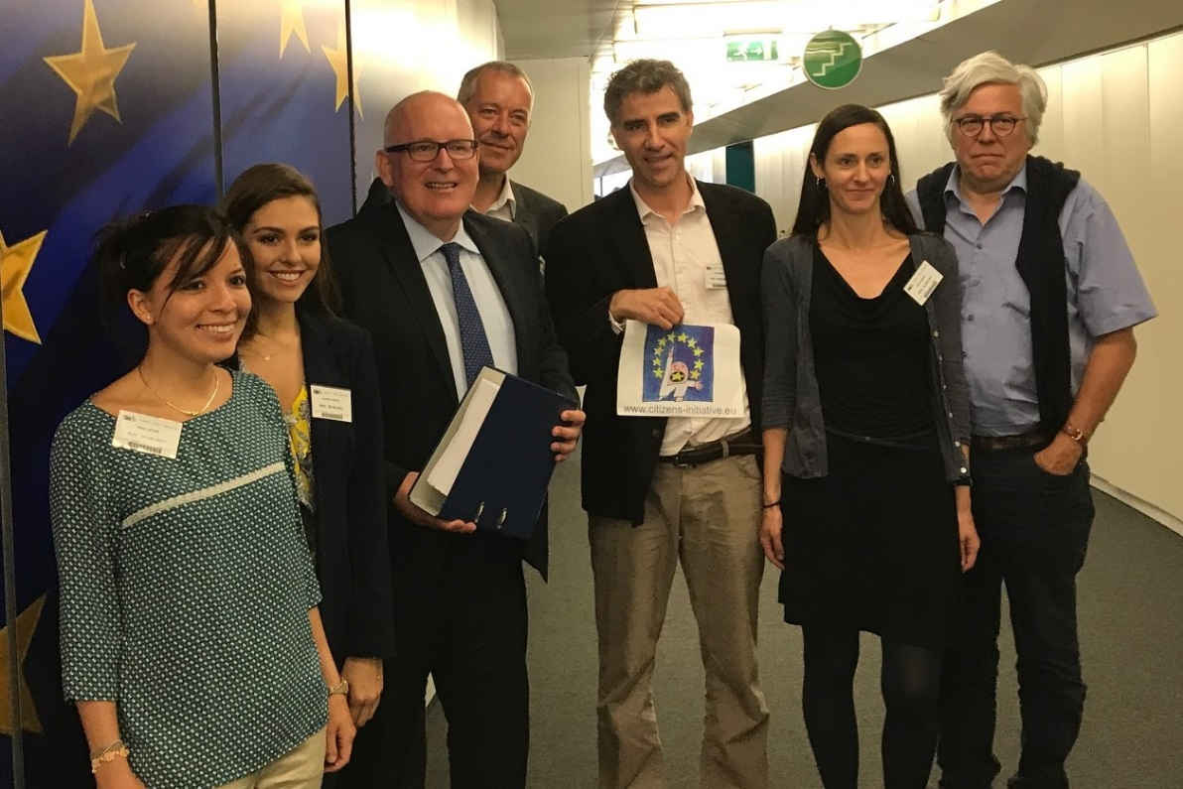

The ECI Watch bimonthly newsletter also continued in 2017: http://ecas.org/category/eci-watch/

Projects

DEEP-Linking Youth
ECAS implemented the ‘Digital Ecosystem for E-Participation Linking Youth’ (DEEP-Linking Youth) project, under the Erasmus+ programme, which ran for two years and ended in November 2017. ECAS led a consortium of 7 European partners working in the field of e-democracy and youth participation. The project combined online and offline activities to test e-participation as an instrument to foster young people’s empowerment and active participation in democratic life
In its final year, the project began with the Digital Competition, calling young people to create their own online content on the subject of youth mobility. Out of the 63 participants who joined the Competition, six winners were selected and invited to attend the Digital Democracy Day 2017 in Brussels.
Two Live-Chats were also organised to allow online interaction between young citizens and EU policy-makers (Brando Benifei, MEP, and Lloyd Huitson, Policy Officer at the EC).
The project partners also finalised the ‘Digital Dashboard’, which is an innovative tool made to monitor what young people are voicing online, especially learning mobility programmes such as Erasmus. The Digital Dashboard aids the understanding of the concerns of young people and allows decision-makers to take their perspectives into account in policy-making processes.
Two final reports provide the project results and recommendations on youth e-participation and youth mobility in the EU. Website: http://deeplinkingyouth.eu/

EUCROWD
The European Citizens Crowdsourcing (EUCROWD) project, under the Europe for Citizens programme, started in September 2016 and continued to be implemented in 2017 by the Institute for Electronic Participation (INePA), in partnership with 8 organisations, including ECAS. EUCROWD aims to raise awareness amongst citizens of e-participation mechanisms at national and European level, with a focus on the possibility of crowdsourcing legislation at EU level
Throughout 2017, the partners organised national public events (in the Netherlands, the UK, Greece, France, Finland and Latvia) following the framework based on the study developed by ECAS on crowdsourcing practices worldwide. The purpose of these events was to foster a democratic debate on the future of the European Union and inform citizens of the crowdsourcing method as a way for them to participate in policy-making in a constructive way and work together with decision-makers.
The conclusions from the conferences organised by the project partners led to recommendations for EU policy-makers on which policies could be crowdsourced at EU level, in which timeframe of the legislative process and which e-participation tools could be used.
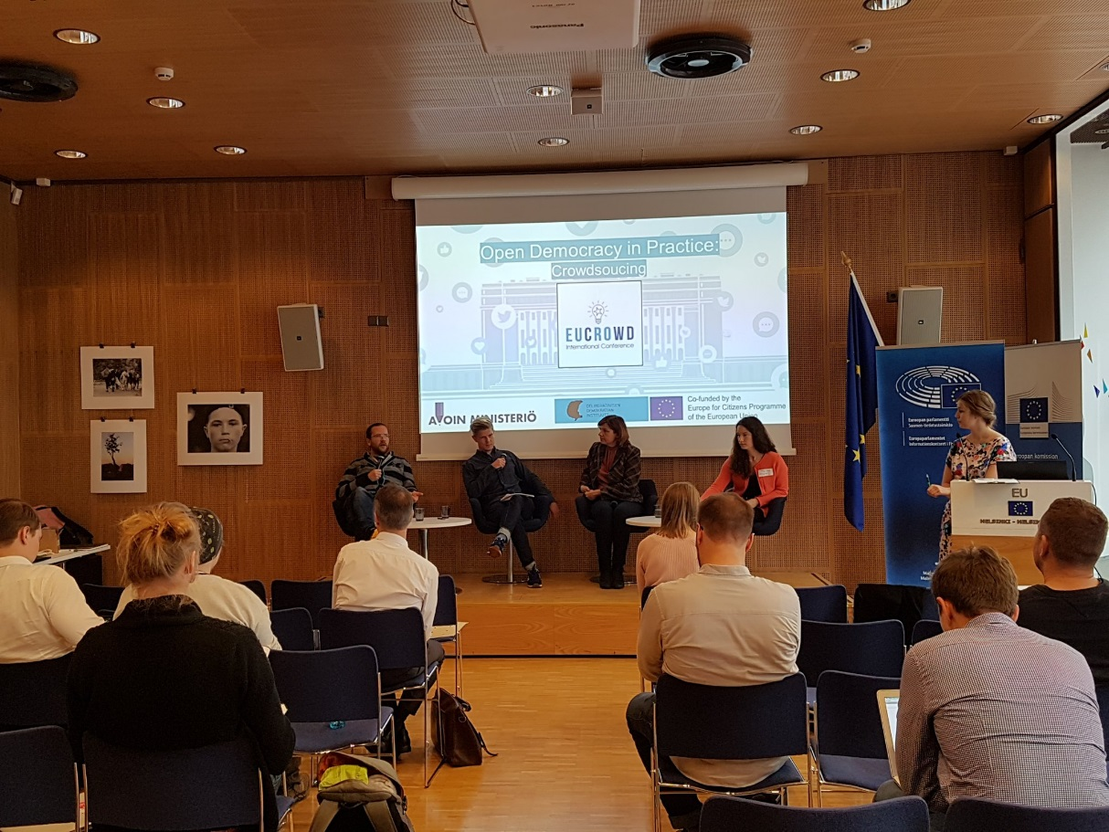

Events

ECI DAY 2017: I participate!
‘ECI Day 2017: I participate!’ took place at the Economic and Social Committee (EESC) on 12 April 2017 in Brussels. Organised by the EESC in cooperation with several civil society organisations, including ECAS, it represents an important annual meeting to exchange ideas on the European Citizens' Initiative (ECI) as a tool for participatory democracy in the EU. The opening session focused on 60 years of European Citizenship and how the role of citizen participation has evolved. European Commission Vice-President Frans Timmermans took this occasion to announce the Commission´s important plans to revise the ECI Regulation by the end of 2017.

The two main workshops of the ECI Day were: ‘The ECI Success Stories’ and ‘Citizen Participation – ECI and beyond’. The first focused on the positive changes thanks to some ECIs that have taken place and the ideas that found their way into European legislation.

ECAS took part in the second workshop that allowed participants to discover new forms of citizen participation that complement the ECI. The discussions were around improving EU policy consultations, using local level engagement methods to address EU issues, EU civic education, online crowdsourcing, transnational activism and civic innovation. ECAS gave its contribution on youth online engagement by explaining to participants how ‘social listening’ mechanisms work and how an online dashboard can monitor young people’s opinions and have an impact on policy-making.
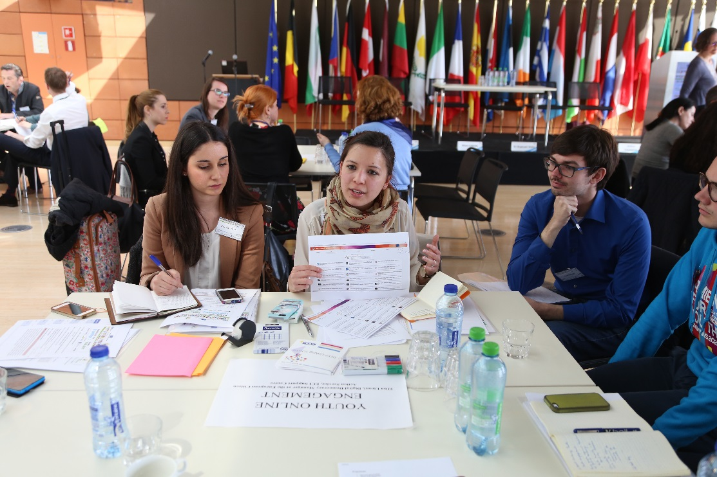

EESC Civil Society Days
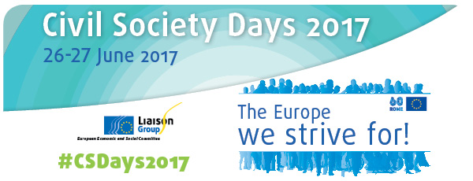
On 26-27 June, the EESC’s Liason Group organised its annual Civil Society Days. This year’s theme was "The Europe we strive for!", constructed around civil society's call for a new political impulse to relaunch the EU on the basis of our values and roots and also give a clear commitment of civil society organisations to forge ahead. The CSDs focused on four themes: populism, technological revolution, empowerment of civil society organisations, and urban and rural dimensions.

In this framework ECAS organised a workshop on “New technologies and transition - What role for civil society in a future of e-democracy?” We started with a brief presentation of a study commissioned to ECAS by the EESC on EU online consultations and the role for the EESC and CSOs. This was followed by a panel discussion where the experts all concluded their presentations with a few recommendations. The recommendations were voted online upon in the last part of the workshop and participants agreed that the role for civil society should mainly be:

• As the infrastructure of e-democracy – bridging the gap between politics and citizens, between technology and actual political results;
• Digital skills development – provide learning opportunities on digital skills combined with the development of critical thinking.

Digital Democracy Day 2017
On 17 October 2017, ECAS held its third annual Digital Democracy Day - Rejuvenating Europe: Opportunities in the Digital World – focusing on identifying the most common challenges to youth participation in European policy-making and proposing several concrete solutions to them by using digital tools.

The event represented the final conference of the Erasmus+ project Deep-linking Youth, a partnership between ECAS and six other organisations, in order to explore and test out different ways of engaging young people in the EU’s democratic life.

Over 110 participants took part in the conference and the event has been viewed over 8,000 times online. The conference featured two panels of expert speakers and explored:
- Challenges facing young people today, especially youth participation in policy-making
- Potential solutions to addressing youth engagement through digital tools

Our special guest, Brando Benifei MEP, also announced the winners of our DEEP-linking Youth Digital Competition. After the panel discussions, we held a mini exposition showcasing three other youth projects on e-participation.
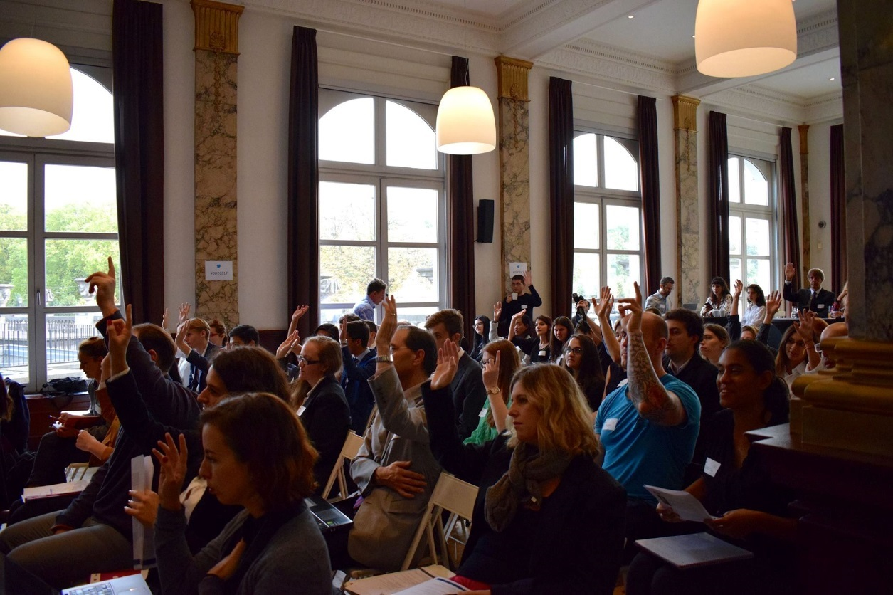
Final Report: http://ecas.org/wp-content/uploads/2017/11/DDD-2017-Report-final.pdf
Videos and presentations: http://deeplinkingyouth.eu/event-report-ddd-2017/

Beyond Fake News: A Workshop on Media Literacy and Fact Checking
On 26 September 2017, ECAS hosted a workshop by the European Association of Viewers’ Interests (EAVI) on the fake news, media literacy and shifting media landscape.

Paolo Celot, Secretary General of EAVI, opened the workshop by introducing the concepts of fake news and media literacy, and discussed the implications of fake news for the individual and society. He looked further at media literacy and the competences that are needed to understand media messages and identify fake news.
He was followed by Luc Steinberg, Media and Project Officer at EAVI, who examined the reasons why fake news exists and what can be done to counter it, and placed it in the context of media literacy. He finished by examining the different kinds of fake news and the motivations behind them.

The workshop closed with a game, ‘Beyond the Headlines – The Online News Verification Game‘, in which the participants dissected different examples of fake news.

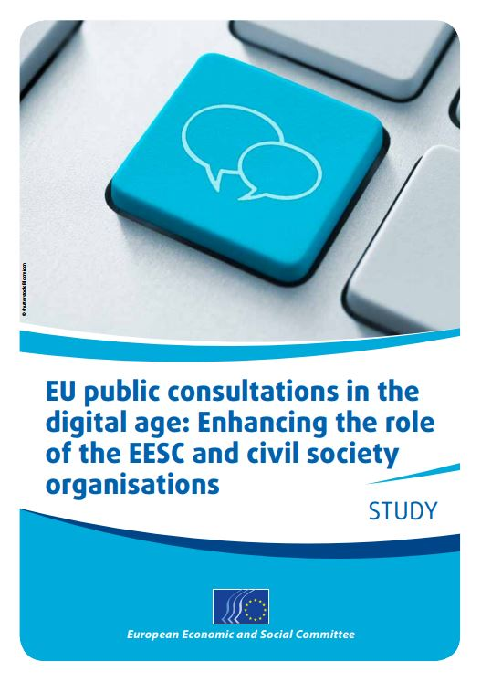
Research Studies

EU Public Consultations in the Digital Age: Enhancing the Role of the EESC and Civil Society Organisations
In 2017, the European Economic and Social Committee (EESC) commissioned to ECAS study on the ‘EU Public Consultations in the Digital Age: Enhancing the Role of the EESC and Civil Society Organisations”, which was officially published in October 2017.
The study provides an analysis of the current consultation practices at the European Commission as well as to examine the potential of an intermediary body, such as the EESC, and organised civil society, in improving this tool for participatory democracy in the EU. The objectives are to identify the main challenges of EU online public consultations, analyse the current role of the EESC and CSOs in these processes and propose recommendations to the EESC on how it could play a more substantial part in overcoming the primary weaknesses of EU online public consultations.
Study: http://www.eesc.europa.eu/sites/default/files/files/qe-07-17-001-en-n.pdf

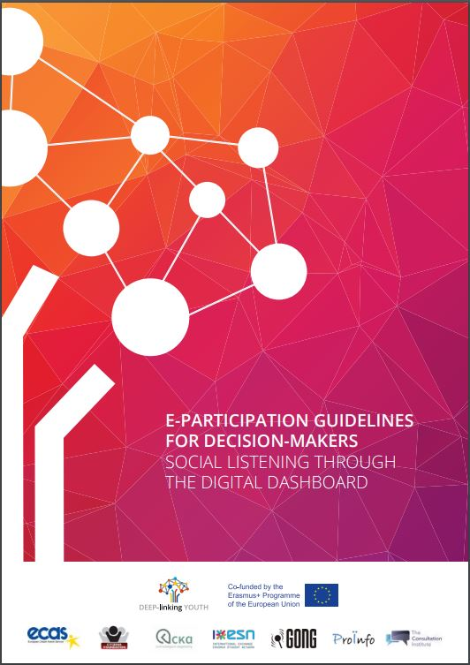
E-Participation Guidelines for Decision-Makers: Social Listening Through the Digital Dashboard
As part of the DEEP-linking Youth project, ECAS developed a set of guidelines for decision-makers on how to use e-participation as an instrument to engage young people and stimulate their active participation in democratic life.
The guidelines are based on the outcomes of the project, which involved examining different ways to reach out to young people using digital tools and the creation of an online Digital Dashboard for policy-makers to listen to the views of young people, particularly those who do not typically engage in decision-making processes.
Through the two main activities, the project highlighted the need to better understand the digital psychology behind young people’s willingness to participate politically and demonstrated the value of a Digital Dashboard as a tool for gathering and extracting data.
The main recommendations are:
- That stakeholders, politicians and organisations experiment with the Digital Dashboard as a
tool that can complement continual engagement or as an aid to a policy-making process.
- That the Digital Dashboard is tested with a more specific or even ‘controversial’ topic for
future research.
- That policy-makers should commission online content generated by youth audiences in the
pursuit of engaging with them.
- That digital education is necessary so that more young people are educated about data
mining and the repercussions of their online behaviour.
http://ecas.org/wp-content/uploads/2017/10/Eparticipation-Guidelines.pdf

Recommendations on Learning Mobility: Insights from the Digital Dashboard
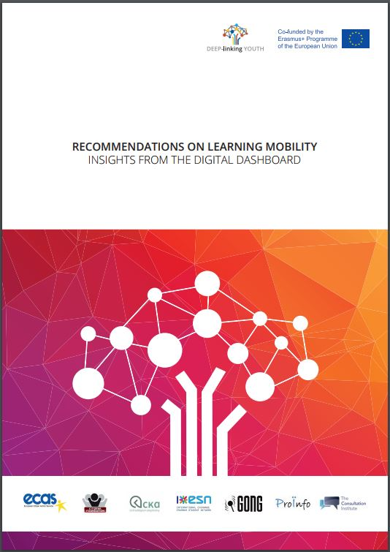
This report is part of the project DEEP-linking Youth, co-funded by the European Commission, and contains findings from the project’s Digital Dashboard. The insights were gained over a one-year monitoring period of social media content relating to learning mobility programmes from all key social media platforms originating from all of the countries eligible to participate in the Erasmus programme. Through the monitoring of the Digital Dashboard, we extracted insights on certain aspects of learning mobility programmes to provide recommendations and to improve EU policies regarding youth mobility. This is feedback based on the observation of real social media messages where we think the learning mobility programmes, especially Erasmus, could be improved or where further investigation is needed.
http://ecas.org/wp-content/uploads/2017/10/Recommendations-to-policy-makers-on-learning-mobility.pdf

Policy Positions

PETI Hearing - Restoring Citizens’ Confidence and Trust in the European Project"
In June 2017, the Committee on Petitions of the European Parliament (PETI) organised a public hearing entitled "RESTORING CITIZENS’ CONFIDENCE AND TRUST IN THE EUROPEAN PROJECT", in the European Parliament in Brussels. ECAS’ Digital Democracy Manager was invited as a speaker on the panel “Enhancing public trust in the European Project - Bridging the gap between promises and delivery” and gave a contribution on the possibilities of e-participation and crowdsourcing in the EU as a means to enhance citizens’ trust in policy-making.

Contributing to EU political groups and think tanks
ECAS Digital Democracy Manager was invited as an expert to contribute to events organised by several political groups and think tanks. In February, ECAS was invited by Julia Reda MEP to participate in the Greens/EFA ‘European Ideas Lab’, mainly in the workshop on participative democracy and access to information. In June, ECAS was invited to contribute at Foundation for European Progressive Studies (FEPS) annual event ‘Call to Europe’ – VII edition, this time focusing on the topic ‘Democracy First!’. In November, ECAS was also present as an expert at the roundtable ‘eDemocracy and eParticipation in Europe. The way forward?’ organised by the European Liberal Forum in the European Parliament.

DG CONNECT Future Of Government 2030+ - Participatory Workshop
In November 2017, ECAS was invited to join DG CONNECT’s workshop on the Future of Government 2030+. This workshop aimed at initiating a strategic debate on shifting power relationships between citizens and other actors and government. ECAS worked with other organisations to develop a proposal on how could governments work in the future, mainly by giving citizens more ways to participate in democratic societies and co-deciding on legislation with decision-makers.

ECAS’ Response to the Public Consultation on the European Citizens’ Initiative
In response to the European Commission’s public consultation on the European Citizens’ Initiative (ECI), ECAS made the following recommendations:
- Citizens’ initiatives should also foster transnational debates between both like-minded and different-minded citizens.
- Civil society organisations have an important role to play in supporting e-participation mechanisms at institutional levels. A few NGOs are already supporting ECI organisers in their own capacity but it is essential to have the involvement of more organisations both at national and EU level.
- Citizens’ committees of an ECI should, within the regulation, be defined as a legal body of EU-lawmaking, so that organisers cannot be held individually liable.
- The Commission should make the most concrete, detailed communication possible in its follow-up to initiatives that reach the required number of signatures to allow organisers the opportunity to concretely follow-up with their political campaigns and have a political debate with facts and figures provided by the Commission.
- The Commission should insist Member States do their part in communicating the existance of the ECI. For example, where Member States already have national platforms for civic engagement, the ECI should also be published on those web pages.
- The Commission could also reach out directly to national civil society organisations for their support.
- In the short term, the Commission should publish a regular ECI newsletter for organisers, signatories and interested citizens with information about ECIs in a particular field or milestones that ECIs reach.

ECAS’ Call for Enhanced Digital Democracy in the EU at EESC Debate
On 7 March, ECAS’ Director, Assya Kavrakova, called for an enhanced digital democracy for the EU in the European Economic and Social Committee’s (EESC) ‘Towards a Sustainable Europe’ debate.

In her intervention in the debate, on the digitalisation of society and the transition to a new economic model, Ms Kavrakova addressed the impact of digitalisation on the future of democracy and elaborated on the transformative power of e-democracy to reshape our political institutions.

Since citizen engagement tools in the EU are “limited in quantity and efficiency”, e-participation methods such as ‘crowdsourcing’ have the potential to enhance participation, strengthen political legitimacy and restructure the relationship between decision-makers and citizens into more of a partnership.

ECAS welcomes Parliament’s e-democracy report
MEPs backed a report by rapporteur Rámon Jáuregui Atondo on 16 March on e-democracy in the EU, supporting greater use of internet voting and e-participation tools as a way of enhancing traditional methods of participation, widening inclusion and reinforcing democratic processes.

The Parliament’s e-democracy report is largely based on the findings of ECAS’ study for the AFCO Committee ‘Potential and Challenges of E-Participation in the European Union’, which recommended that the EU “both improve existing e-participation tools and foster new ways of e-participation”. This would bring significant benefits, including “enhancing participation and active citizenship”, “engaging young people in policy-making”, ensuring innovation in policy-making and increasing “political trust and legitimacy”.

The stand-out mechanism for this is ‘crowdsourcing’, which would harness the ‘wisdom of the crowd’ to enable citizens to interact with government, and the report calls for pilot projects to be launched from local to EU level.

The report further calls on the Commission to reform the European Citizens’ Initiative to enable it to reach its full potential, use the mid-term review of the Digital Single Market Strategy to expand and develop e-participation, and emphasises the importance of access to information, digital literacy and a high-speed internet infrastructure.

Digital Democracy Could Engage Citizens in Europe – ECAS’ Director in Europe’s World
On 2 October, Europe’s World featured an article by ECAS’ Director Assya Kavrakova on democracy in the digital age and the potential role digital technologies can play in enhancing citizen participation and youth engagement at EU level.

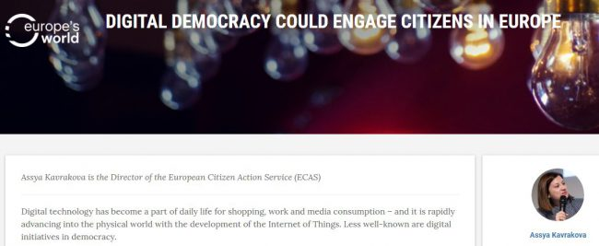

In her contribution, Assya Kavrakova introduced a number of digital initiatives that have been employed at national level in EU Member States, and that have been analysed by ECAS, in order to assess how digital democracy could positively affect democratic processes and lead to democratic innovation.

In order to maximize the benefits and opportunities descending from the employment of digital tools, however, further actions need to be undertaken at EU level, such as the development of sound policies on privacy and media literacy, as well as the promotion of new media and both on-and off-line activities.

To reduce the gap between themselves and citizens and transform the relationship into a partnership, EU decision-makers should embrace democratic innovation. They can do this by developing digital democracy policies for citizen engagement as an integral part of the Digital Single Market. Moreover, they should use digital tools to interact with young people where they naturally are – in the digital space – instead of waiting for young people to engage in politics as currently practised.

Digital democracy has the potential to contribute to the rejuvenation of the European project and to the creation of an engaged citizenship. This can happen only if both decision-makers and citizens grasp the opportunities of the digital transformation.

ECAS Services to Members and Civil Society Organisations

Services to Members
In 2017, ECAS continued to provide a package of services to its network of 80 members. This package included:
- Free access to ECAS’ annual European Funding Guide for the Non-Profit Sector.
- Monthly funding alerts on open calls for proposals and tenders.
- Dedicated space in our bimonthly newsletter to advertise their organisation, projects and activities.
- Information about info days, conferences and other relevant networking events organised by the European Commission and its executive agencies; general guidance and timely advice on particular projects or funding programmes.

ECAS Newsletter (bi-monthly)
Since January 2016, ECAS has been issuing a bi-monthly newsletter. Subscribers have increased from 1,600 in January 2016 to 2,500 in January 2017 to 3,000 at the end of the year.
The newsletter is structured around ECAS’ 3 focus areas - EU Rights, Beyond the EU and Digital Democracy. It serves to promote our activities, and those of our members and partners, and to inform our stakeholders, and citizens in general, about the main ongoing initiatives at EU level relevant to our areas of work, while enabling them to participate and have a say in the discussions.

ECAS Funding Guide for the Non-Profit Sector
ECAS has been producing a European Funding Guide for the non-profit sector for over 23 years. This publication is updated annually with the new programmes and sources of funding available in the EU. The 2015 version was published in a revamped format and layout, offering increased accessibility through an electronic version downloadable in PDF format. ECAS retained the layout for the 2017 edition, in order to maintain the visual identity of the publication, and also kept the additional features from the 2016 edition, such as schemes, tables and pictures, to make the content more appealing. The guide was offered for free to ECAS’ members and for a fee to non-members. It can be purchased online on our website and at European bookstores in Brussels.
Find out more about our services and funding guide

Training Centre
In 2017, ECAS delivered a comprehensive training workshop for the Salvation Army in Brussels on EU funding and project management, focusing on the needs and priorities of their European network. The Salvation Army was provided with a thorough grounding in EU funding programmes and priorities, an interactive session on project applications and management, and a practical exercise in formulating a project proposal.
ECAS also delivered a session on EU funding for Young European Leadership at the House of European History and hosted a delegation of Calalonian organistions interested in EU funding.
Find out more about our Training Centre

ECAS’ Outreach

Overview
In 2017, ECAS increased its output and success across all its media channels and achieved a greater presence in the mainstream media. There was a much higher engagement rate on Twitter and Facebook and a significantly higher number of website visits than in the previous year.

The website had over 103,000 visits, a 46% increase on the previous year and our outreach improved significantly on Twitter and Facebook. Audience engagement showed the most significant improvement, with a 116% increase (number of engagements) on Twitter and a 172% increase (engaged users) on Facebook.

ECAS also featured in a number of leading media outlets, including the BBC, Independent, The Atlantic, Europe’s World, Euractiv and EUobserver, among others. ECAS’ activities on Brexit and citizens’ rights, ECI reform, digital democracy, free movement and EU rights were all covered.

A full list of ECAS’ media coverage can be found here.

ECAS’ Communications
ECAS’ website currently provides information about its identity (mission, vision and values), projects and services to citizens, partners and members, and advocacy activities at EU level. This is supported by social media activities across four channels – Twitter, Facebook, LinkedIn and YouTube.
Detailed statistics of ECAS’ communications are as follows:

Website activity

In 2017, the number of visitors to our website varied between 4,839 in July and 10,964 in January, totalling 90,079 for the year – an increase of 48% on 2016.

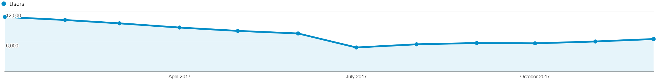

Page views during the year reached a high of 18,497 in January, with a low of 10,281 in August. There were 166,405 in total, representing a 34% increase on 2016.

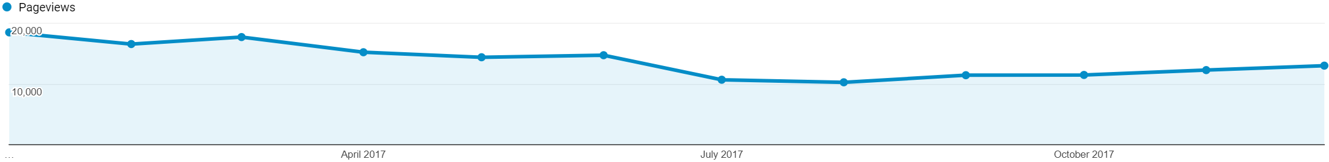

The number of sessions followed a similar trend, with a high of 12,067 in October and a low of 5,884 in July, totalling 103,617. This is a 46% increase on 2016.

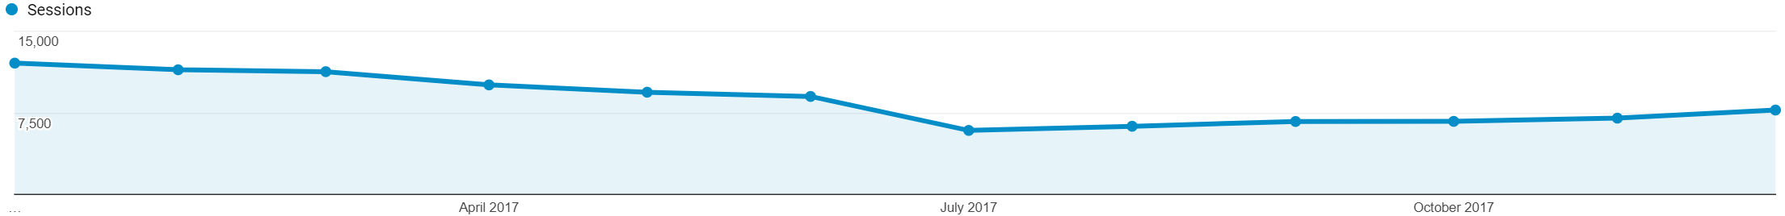

Twitter
At the end of 2016, ECAS had 2,766 followers on Twitter. In 2017, we increased this to 3,732 – a net increase of 934.
In 2017, we posted 1,487 tweets, which produced 1,280,800 impressions (i.e. the number of times a user sees a Tweet on their timeline or in search results).
The average engagement rate per month was 1.03%, with 3,056 retweets and 2,583 likes.

Our top 3 tweets were:

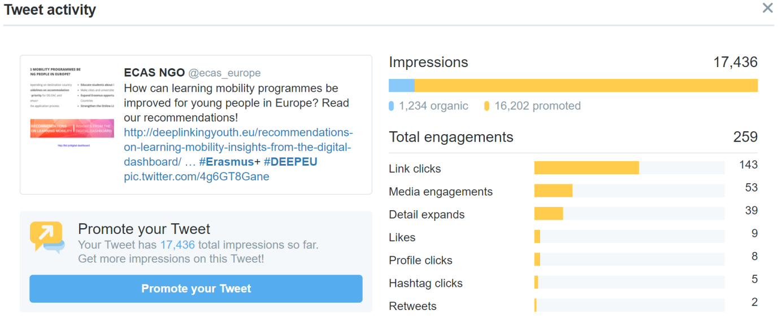
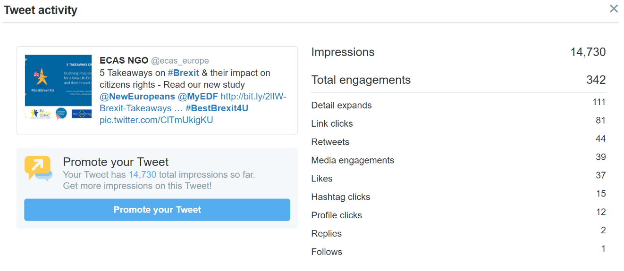
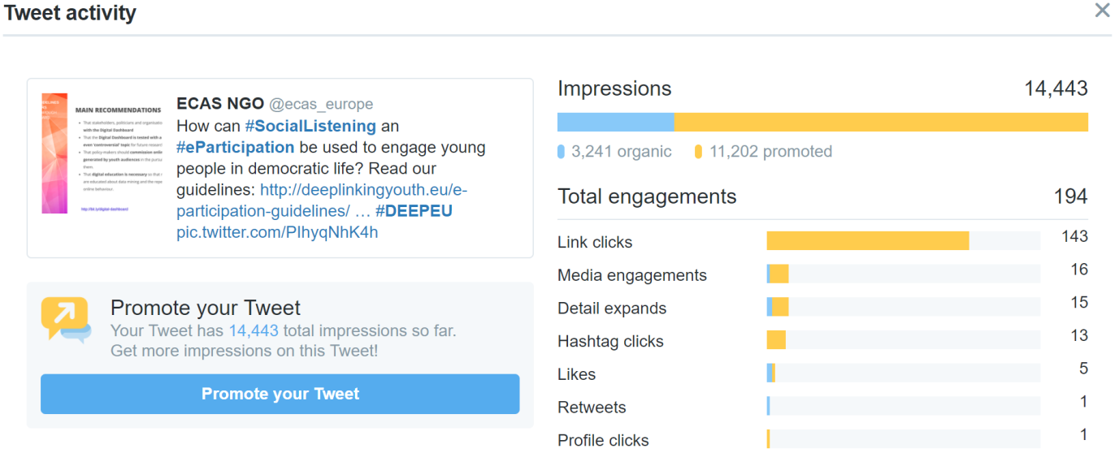

Facebook
In 2017, our Facebook page had a net gain of 1,200 likes, reaching 3,835 by the end of the year.

Our 173 Facebook posts reached 248,834 unique users (381,630 impressions), with 9,604 users engaging with our page.

LinkedIn
In 2016, our followers on LinkedIn increased by 122, reaching 517 by the end of the year.
Our 62 posts during the year reached a total of 33,445 users. We had 983 page views and an average engagement rate of 1.32% per post.

YouTube
In 2017, we published 20 videos on our YouTube channel – ECASBrussels. Over the course of the year, we had a net gain of 14 subscribers, standing at 43 at the end of the year.
Our videos were viewed for a total of 5,530 minutes and received 1,573 views. The average viewing time was 3 minutes 30 seconds.
Our most popular videos were:
- Disability rights in the UK Post-Brexit
  - 276 views
- “Brexit and Citizens’ Rights: The Case of Gibraltar”
  - 134 views
- ECAS' webinar on Brexit implications for citizens' rights 5 Dec 2016
  - 125 views

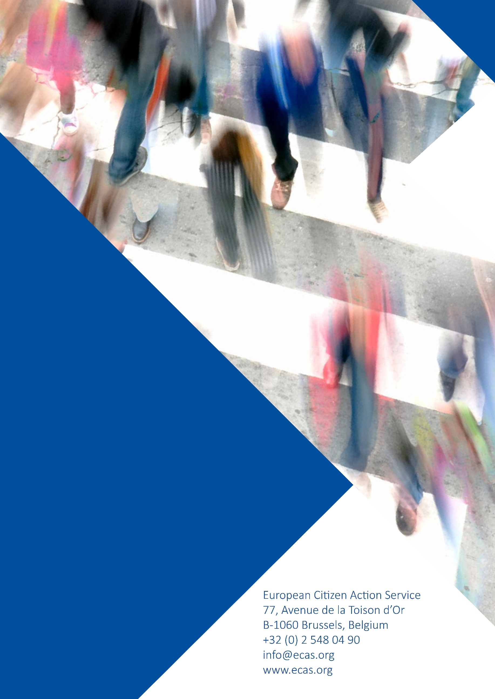

Based on figures provided by the UN and by the UK’s Office for National Statistics (ONS).
Written evidence to the Exiting the European Union select committee - 1 March 2017
Objectif, Belgium, the Immigrant Council of Ireland, the Migrants’ Rights Network, UK, and the Irish Immigrant Support Centre.

