This project is funded by the European Union
Instrument for Pre-accession Assistance (IPA) Civil Society Facility (CSF)

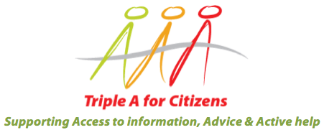

Triple A for citizens, Access to information, Advice and Active help (Triple A)

CALL FOR PROPOSALS (CFP)
Civil Society Organisations (CSOs) who provide information, advice and active help services (which are free and open to all members of the public) are invited to apply for up to 5000 € to develop an Advocacy action/actions related to Information, Advice, and Active Help services.
Closing date: August 31, 2015

Project leader:
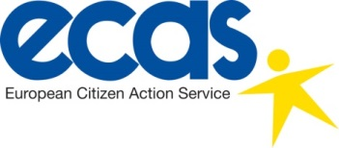
EU Partners:
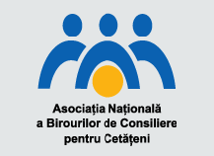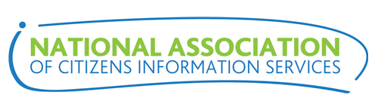
WB & Turkey Partners:
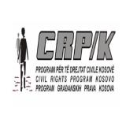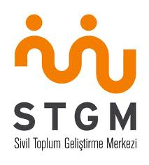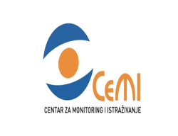

Background to the Triple A Project

The objective of the project is to enhance “the role of civil society in giving citizens a voice and holding governments to account.” By enhancing the connection to citizens, the project will strengthen the role of civil society. Citizens’ information and legal advice services are able to influence government policy on key reforms and their implementation by aggregating the complaints and evidence they receive.

The consortium of organisations implementing the Triple A project aim to continue the work from the initial phase by expanding the concept to Albania, Macedonia, and Montenegro through the sub-granting of a total of 30 000 €, representing six projects (5000 € per project) in total and two per country. Activities under the sub-grant will need to be undertaken between the 1st of October 2015 and 30th of September 2016. In this new initiative, there is an increased focus on advocacy for reforms to improve citizens’ access to information, advice, and active help services.

Before applying, we strongly recommend that you read the Guidelines in order to understand the background of the type of organization we would like to support under Triple A. You can also find out more on the project here, and a brief description of several pilot projects which were accepted for the first phase of the project can be found here.
The deadline for submission of proposals in response to this CFP is the 31st of August 2015.

Eligibility
To be eligible for a sub-grant, your organisation must be registered as a non-governmental organisation in Macedonia, Montenegro, or Albania, and be willing to participate fully in the Triple A Project as a Pilot Organisation. Participation as a Pilot Organisation in the project will involve:
- Supporting an Advocacy roadmap and campaign with the lead partner organization in your country to provide evidence to legislators that the provision of information, advice and active help to citizens is important not simply because of the EU acquis but that it also enhances social cohesion and provides a channel through which citizens can air their grievances, which can help evaluate the effectiveness of public policies. This can be done at either national or local level.
- Provision of an Information, Advice & Active Help Service on a wide range of issues, which is accessible to all. This may include provision of free legal advice.
- Developing minimum Quality Standards in line with those set out by the Triple A project.
- Commitment to the principles of independence, equality, impartiality and confidentiality in the provision of Information and Advice Services.
- Developing or improving a recording system (if one is not already in place) to enable your organization to track information, statistics, and evidence on the impact of policy issues which affect people using your service, and highlighting these issues to relevant bodies in conjunction with the national partner.
- Joining and contributing to the development of the pan-European network of Triple A providers based on the commitment to common quality standards and the learning of best practice methodology amongst its members.
- Working with a Partner/Mentor with experience of developing and providing similar services.
- Undertaking study visits to mentoring partners’ countries. This will involve visits to London, United Kingdom; Dublin, Republic of Ireland; and Bucharest, Romania. The cost of the study visits will be paid for by the Triple A Project in addition to any grant awarded and they will take place in early 2016. As the study visits and mentoring will be conducted in English, those who will be directly involved in implementing the project are expected to have a high level of English Language skills.
- Willingness to provide monitoring information and data relating to the sub-grant and to comply with the terms and conditions of funding.
- Signature of a Partnership Agreement.
- Complying with the visibility requirements of the EC as stipulated in the partnership agreement.
Please confirm your organisation is willing to comply with the 11 points above Yes No

Criteria
We have set up a list of criteria that will be taken into account for the selection of pilot projects. In addition to answering the questions in the form, please ensure that you provide evidence in your answers which demonstrates how your proposed work addresses the following evaluation criteria:

Organizational Capacity
Demonstrates how the Aims and Mission of the organisation complies with the Triple A objectives as outlined in the Guidelines.
Provides evidence that the organisation has the necessary skills, experience and ability within the organisation to undertake the proposed work.
Provides evidence that the organisation is sustainable with sufficient funds.
Provides evidence that the organisation is accessible and targets those who are most in need.
Provides evidence that the organisation believes in implementing equal opportunities and diversity both in terms of the services delivered and recruitment of staff and volunteers.
Provides an Information, Advice and Active help service which advocates on behalf of beneficiaries to access their rights and entitlements. This may include providing legal aid within the legal framework of the beneficiary country.
Project
Clearly demonstrates the objective and the added value of the project.
Provides clear identification of the problem/problems to be addressed through the advocacy action/actions.
Clear and coherent description of the advocacy action/actions to be carried out, their feasibility, relevant stakeholders (target, beneficiaries, supporters) and the results to be achieved.
Provides evidence that the project is sustainable: it aims to have a lasting impact beyond the timeframe.
The organization has a clear strategy for developing/enhancing partnerships in the proposal through a willingness to collaborate with other organizations, share best practices, learn with others, etc.
Provides a viable budget for the pilot project.

Please complete all sections of this proposal:
- All text should be Calibri - font size 12
- Your outline (three following sections + narrative) should not exceed 10 pages (not including CVs of key staff members), with the template format unchanged. Pages in excess of this limit will be discounted

Section 1: About Your Organization
1.1 Organization Information
1. |  | Name, Address, and website of Civil Society Organisation (CSO).
2. |  | Contact person within your organisation regarding this CFP (please include full contact details).
3. |  | What is the legal status of your organization?
4. | Please list the mission, vision, and values of your organisation.
1.2 Organizational Capacity
5. |  | How many people are employed by your organisation and what are their working positions? What is the percentage of voluntary work in your organisation? How many of the employees/volunteers are dealing with the information, advice, active help and advocacy services you are providing (if any)?
6. |  | Where does your current funding come from? What does it cover? (Please list the main financial sources by their sort and the percentage of the total amount, including any existing self-financing.)
7. |  | Please give the total amount of Income and Expenditure of your organisation in the past three years, listed by year. (If your organisation has not been in existence for three years, please give the number of years and any Income and Expenditure in those years. If you are a completely new organisation please state this in the box below.)

8. | Tell us briefly in your own words about your organisation's experience in the area of information and advice services, stating what services you provide, how long you have been providing them, why you provide them, what you want to achieve by providing such services, how many people benefit from each of these and what social impact (the outcomes) these activities have made.
9. |  | What are the main geographical areas and what social groups does your organisation provide services to? Do you have any experience in establishing coordination with other organisations active in providing similar or closely related services in your region/any other regions - please describe. Do you have branch offices in other cities/regions?
10. |  | How many people were seen last year by your organization, complaints processed, etc.?
11. |  | Please summarise your organisation’s most recent achievements in the area of advocacy, information and advice services.
12. |  | Please provide a short outline of the qualifications and experience of Key Staff members in your organisation, to include Director or Chief Executive. Please include the CV of the individual who would be directly involved in implementing this project. The CVs should be attached as an Appendix to this form.

Section 2: Project Proposal
Please explain the initial proposal for the project you wish to implement should you receive the funds. You will find below some initial guidelines that you could follow for the proposal. Keep in mind the evaluation criteria mentioned on page 6 and make sure to incorporate these into your proposal.
Proposed structure:

Project
- Briefly explain what you would spend the grant on. How would you set up/further develop an advocacy campaign and, if relevant, your Information, Advice, and Active Help services?
- How will you prove that the reforms you are suggesting are necessary, and why do you feel your organization is best suited to do this advocacy work?
- Is the work you intend to do primarily on a local, regional, or national level?
- What are the lasting outcomes you expect from this project?
- How do you plan to make the work done under the project sustainable after the term of this funding, i.e. finding other sources of funding, etc.?
- Who are you trying to influence with your campaign: How do you plan to have an impact on them and ensure that changes are enacted?
- How do you plan to promote the advocacy campaign and to whom?
- Who are the beneficiaries of the advocacy campaign? I.e. citizens, policymakers, etc.
- What kind of added value or innovation can you achieve with this pilot-project?
Partnerships
- How do you plan to incorporate other organizations, governments, relevant individuals, and/or others in your campaign?
Project Budget
- Please complete the Grant Budget in Annex A to this CFP.

Insert the Title of your Project Here

Name of Person Completing this Form:
Name of Organization:
Signature and Stamp:

Date:

Position in the organisation (i.e. Chief Executive, Director, etc.)

Please confirm you have the authority to submit this proposal on behalf of your organisation

...............................................................................................................................

Thank you for responding to this CFP

The completed form should be returned to:

Albania: Besa Ombashi from the Open Society Foundation Albania (OSFA) at besa.ombashi@osfa.al.
Macedonia: Svetlana Kjoseva from the Macedonian Young Lawyers Association at skjoseva@myla.org.mk
Montenegro: Vlado Dedovic from the Centre for Monitoring and Research (CeMI) at dedovic.v@gmail.com

Questions? Contact Tristan Barber from the European Citizen Action Service at tristan.barber@ecas.org.

Closing date: August 31, 2015

An applicant can send only one application to this CFP.

All applications which are not completed in accordance with the instructions given, sent after the closing date, or which fail to meet any other request stated in the application documents will be rejected.
Every applicant will receive an answer in a written form, with the information on the application status, as soon as the selection process ends.

The initial phase took place from December 2012-February 2015, and it spread the Triple A concept to the Western Balkans (Croatia, Bosnia and Herzegovina, Serbia, and Kosovo), and Turkey. In total, ten pilot projects were funded throughout the five countries and over 4000 citizens were reached. Additionally, the capacities of the participating NGOs were improved substantially through study visits and networking with other similar organizations in the region.
Please note that the current goals of the project have been adjusted to include a stronger advocacy component than what is mentioned in the guidelines.
The Advocacy roadmap is currently being developed by the national partners in each country: Open Society Foundation Albania (OSFA), the Macedonian Young Lawyers Association (MYLA) and the Centre for Monitoring and Research (CeMI) in Montenegro. It will present several recommendations and strategies for improving the provision and funding of legal advice services within the country and the action plan will be carried out in 2016.
The network is currently in the development stages and will be launched by mid-2016.
This includes the implementation and use of the recording system (if one is not already in place) for the organization’s provision of services. The data and statistics gathered should be utilized for fact-based advocacy in the project, as mentioned in point 2 of the eligibility criteria.
Some examples (which are non-exhaustive) could include: - Improved national legislation to increase funding to free legal advice services. - A plan to improve the enforcement of current Legal Aid legislation. - Establishing a local network for development of the free Legal Aid sector. - Establishing/Developing relations between local government and providers of Triple A services that can feed into national policy.

